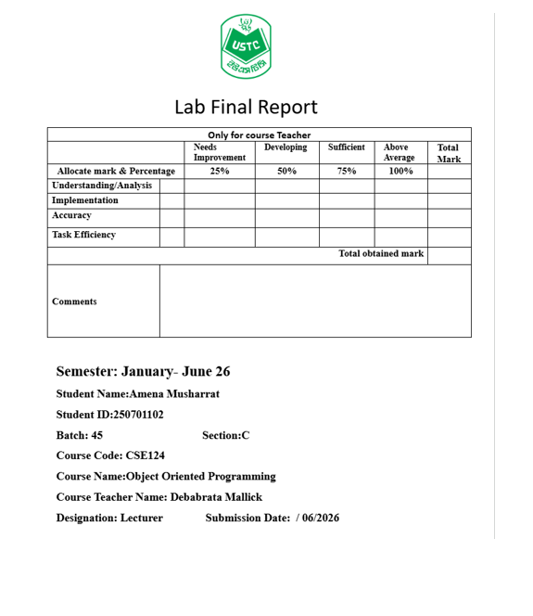
Table of Contents:

Serial No. | Lab Task | Title / Name | Page No.
1 | Lab Task 01 | GitHub and LinkedIn Profile Creation
2 | Lab Task 02 | Visual Studio Code Setup and Java Environment Configuration
3 | Lab Task 03 | Java Basics and W3Schools Problems (Basic to If-Else)
4 | Lab Task 04 | Java Control Statements and Arrays (If-Else to Array)
5 | Lab Task 05 | Hacker Rank Java Problem Solving (Part 1)
6 | Lab Task 06 | Hacker Rank Java Problem Solving (Part 2)

Lab Task :01
https://www.linkedin.com/in/amena-musharrat-2a61823a4?trk=contact-info&authuser=0
https://github.com/amenamusharrat?authuser=0
Lab Task 01 – Explanation:
This task is about creating a GitHub account and LinkedIn profile. First,
- Created and organized a professional profile on GitHub for sharing and managing project repositories.
- Then, built a professional profile on LinkedIn to showcase academic and career information.
- Uploaded and maintained project files to improve version control and project accessibility.
- Used online platforms to build a digital portfolio and strengthen professional networking.

Lab Task :02

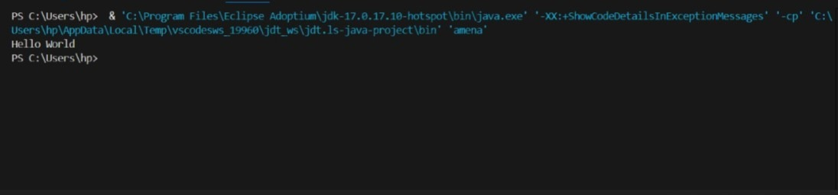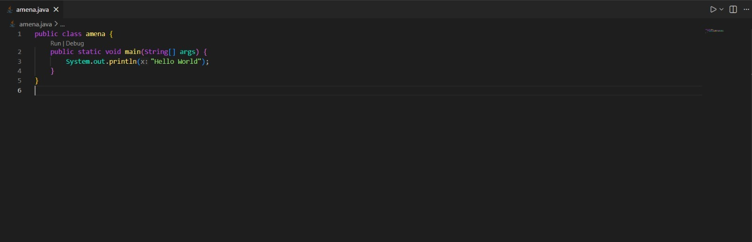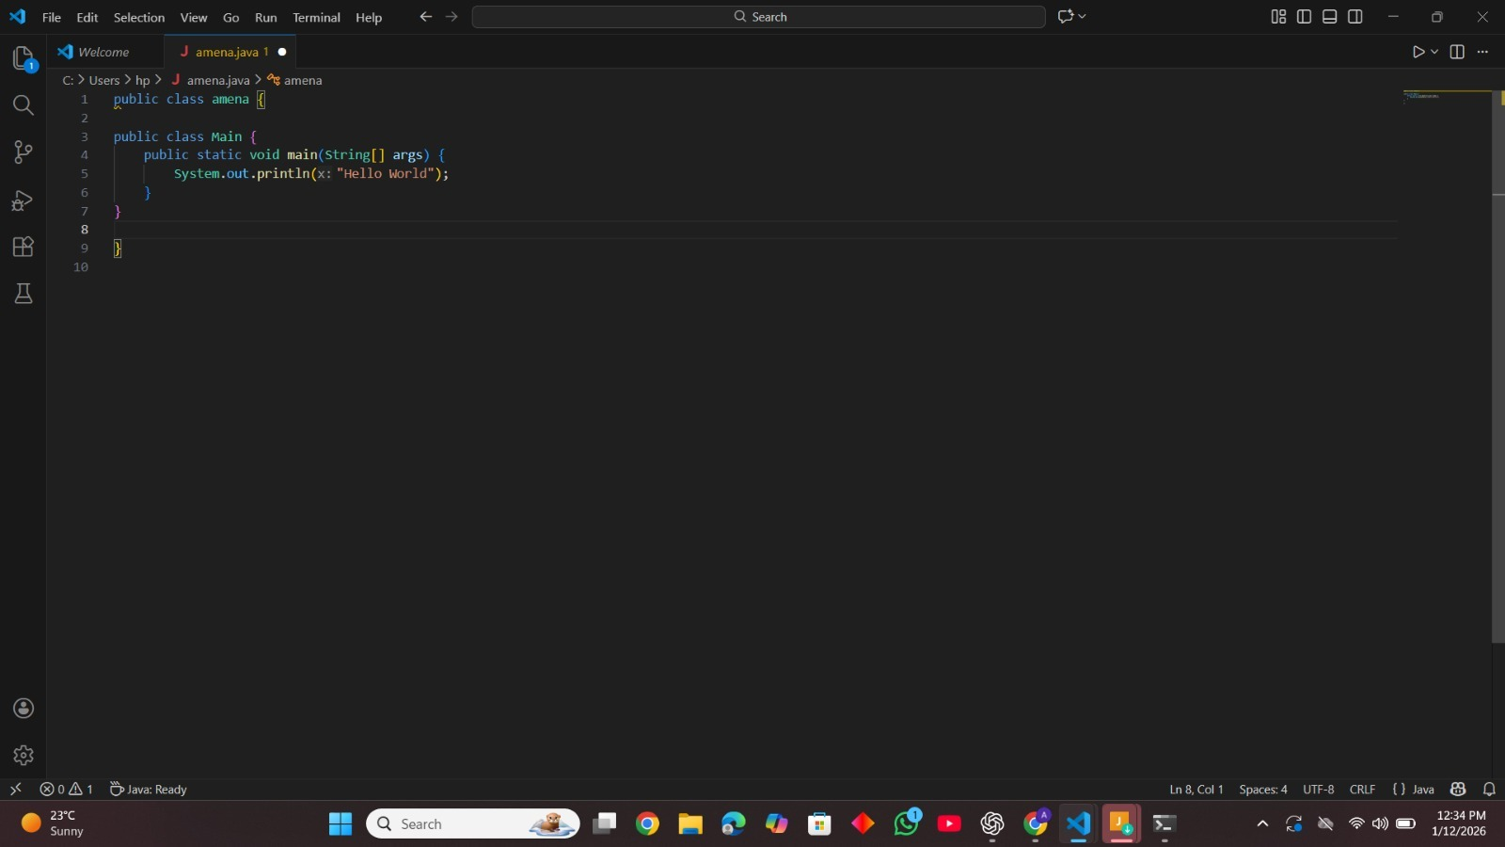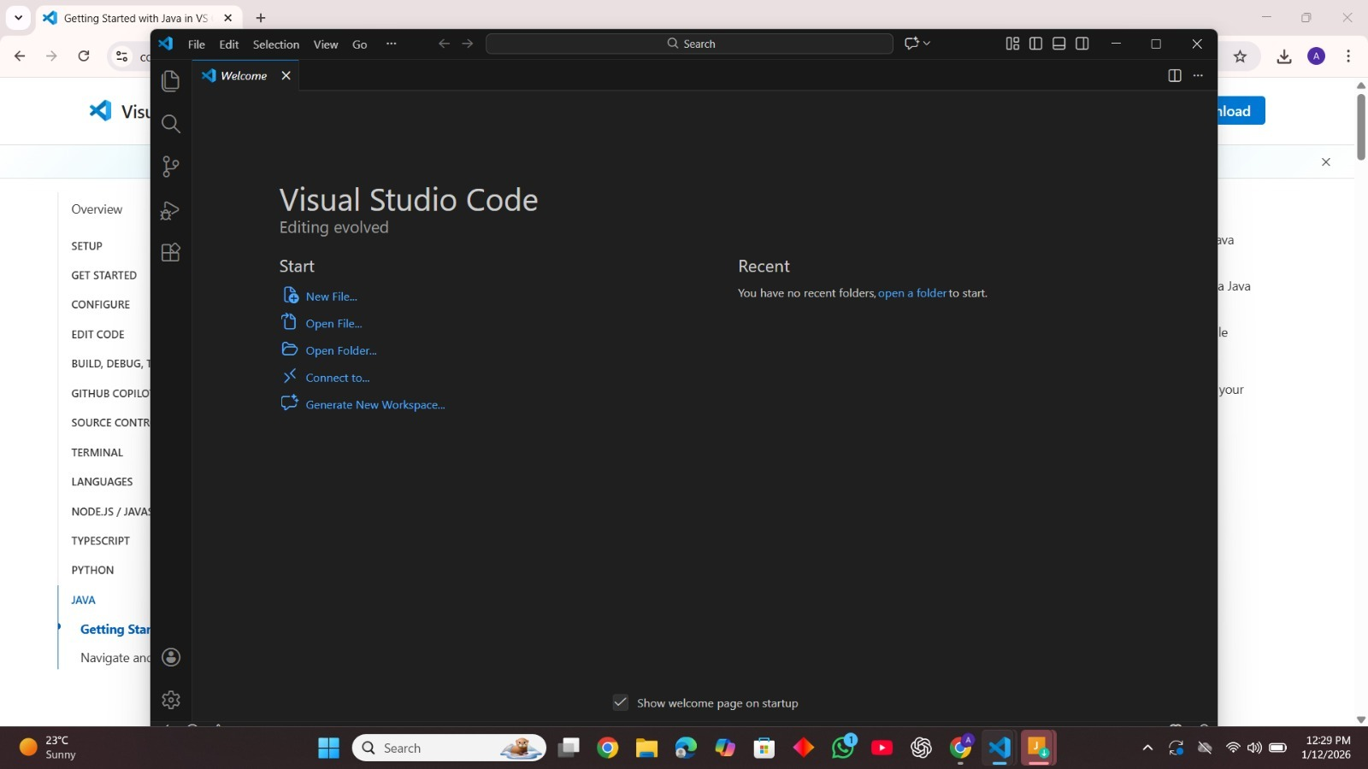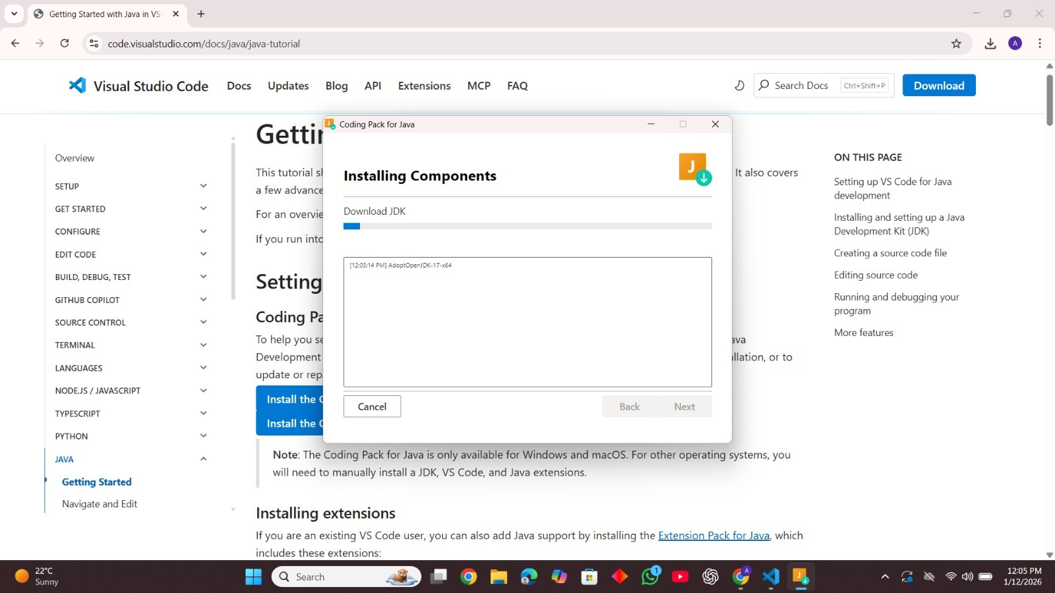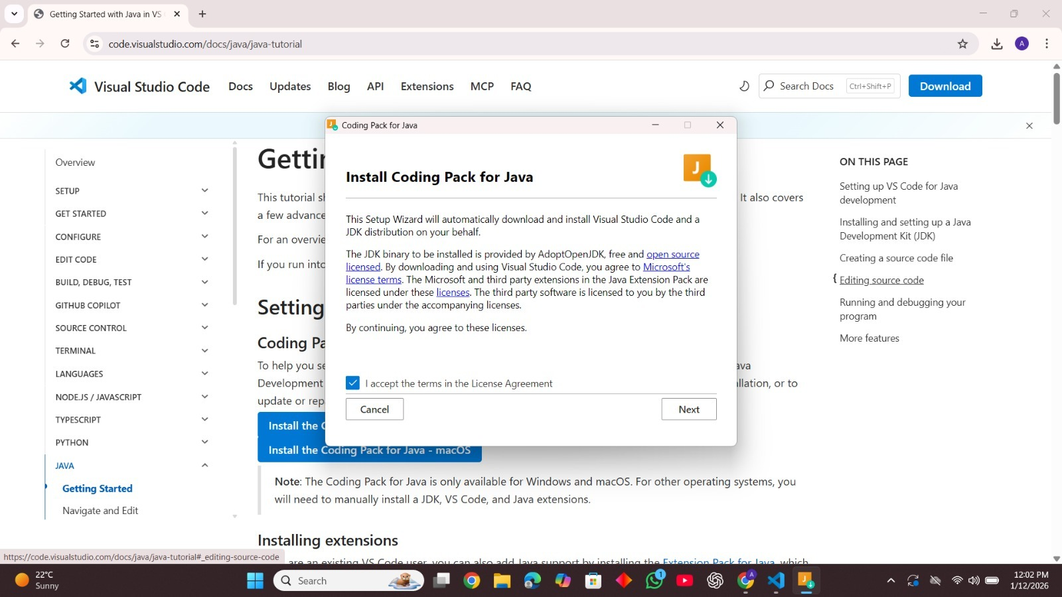
At first, I set up the required environment by installing all the necessary software and development tools like vs code and java installation pack
After installation, I configured the system settings and environment variables properly in CMD (Command Prompt)

Then, I ran a simple test program to check whether everything was working correctly in java version.

Lab Tak :03

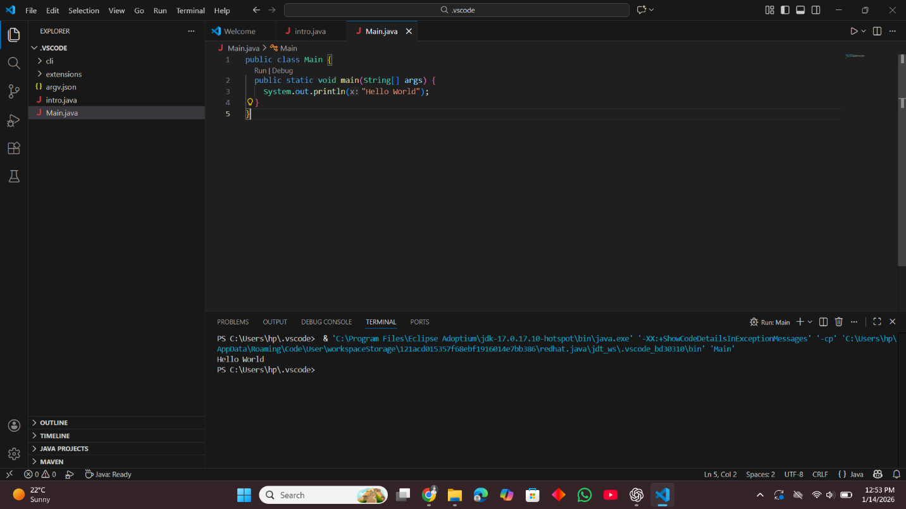
This is a basic Java program that prints a message to the console.
It simply displays "Hello World" when run.

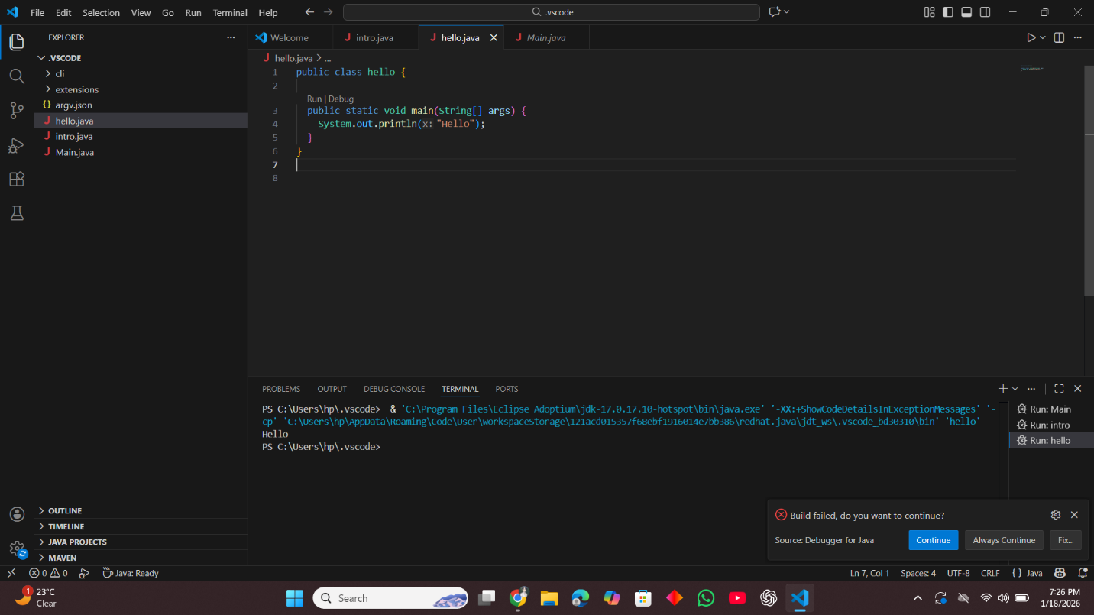
This code prints a simple greeting to the console.
It displays "Hello" when run.

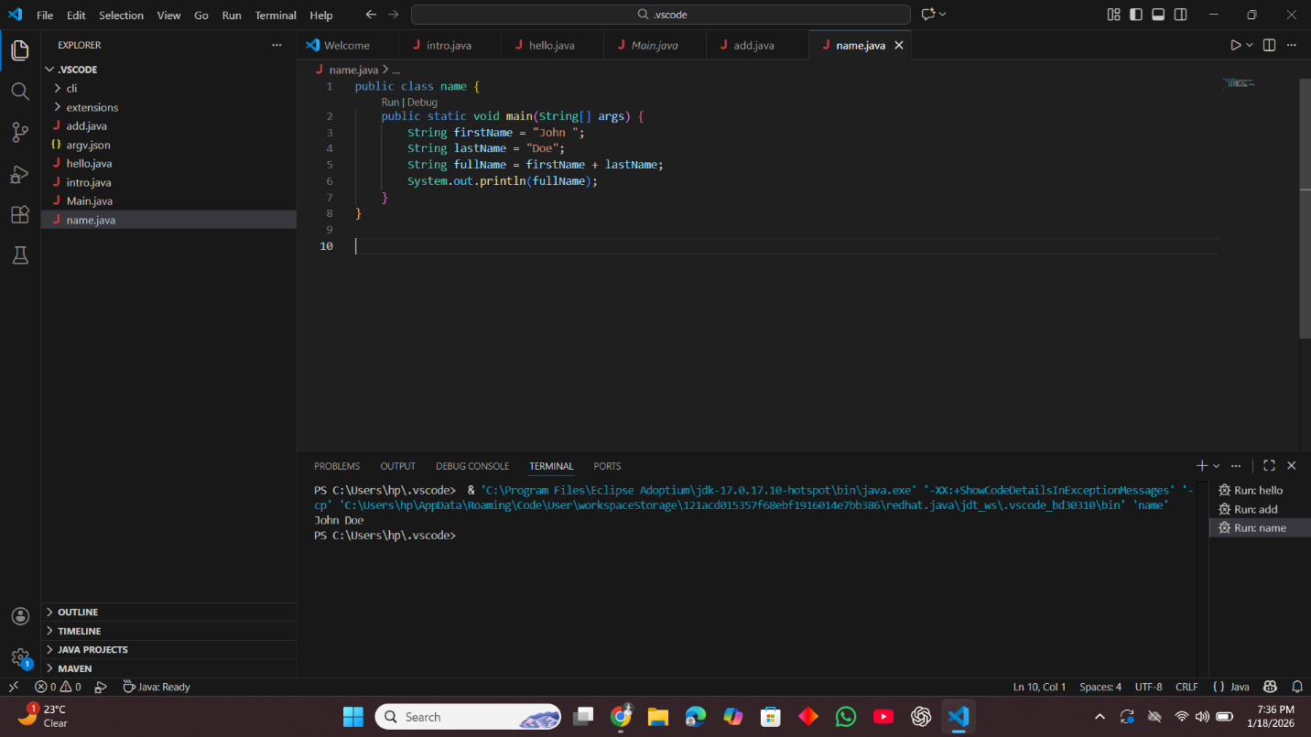
This code combines two string variables, firstName and lastName, into fullName.
It then prints the full name, John Doe, to the console.

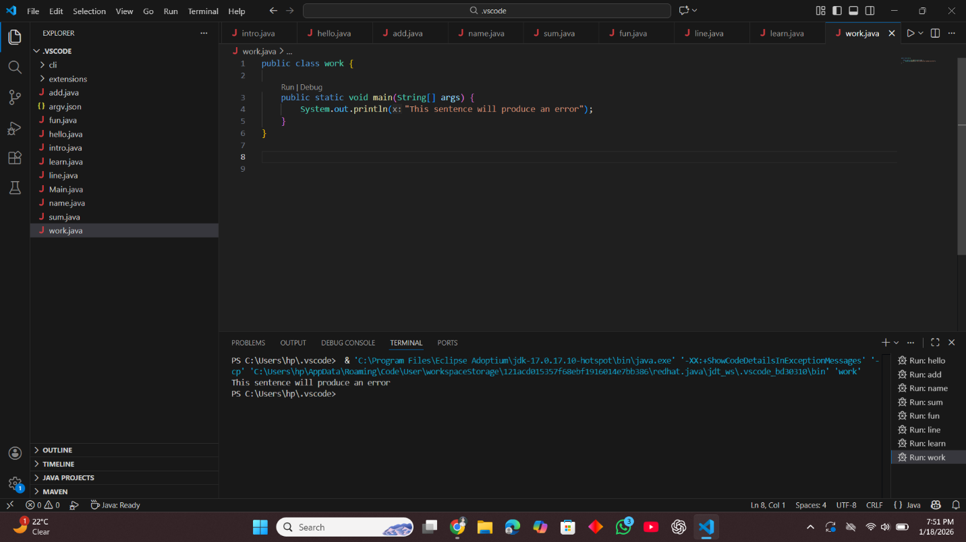

This code uses a string argument inside System.out.println() to display a sentence on the screen.
It simply prints “This sentence will produce an error” as output, even though the program itself has no syntax error.

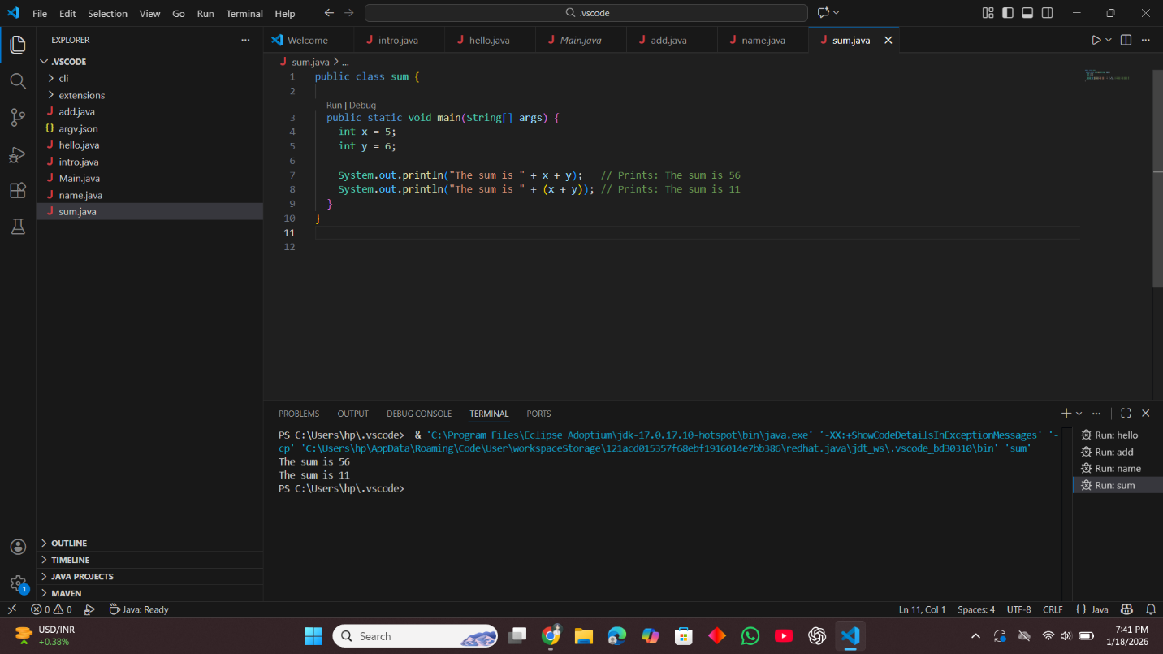

This code shows how string concatenation works in Java.
Without brackets it joins the numbers as text (56), and with brackets it adds them first and prints the actual sum (11).

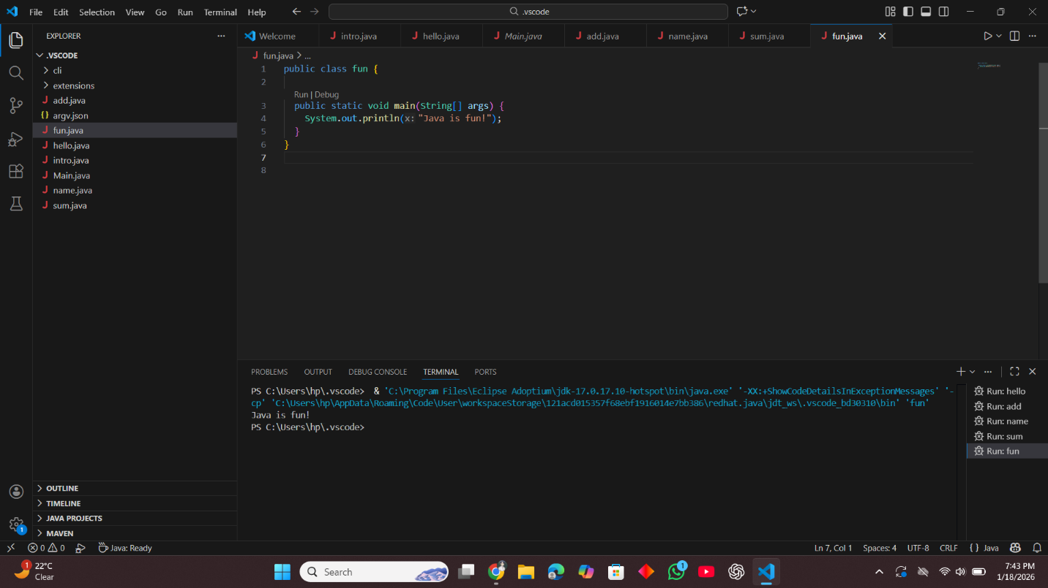

This code prints a short message to the console.
It displays "Java is fun!" when executed.

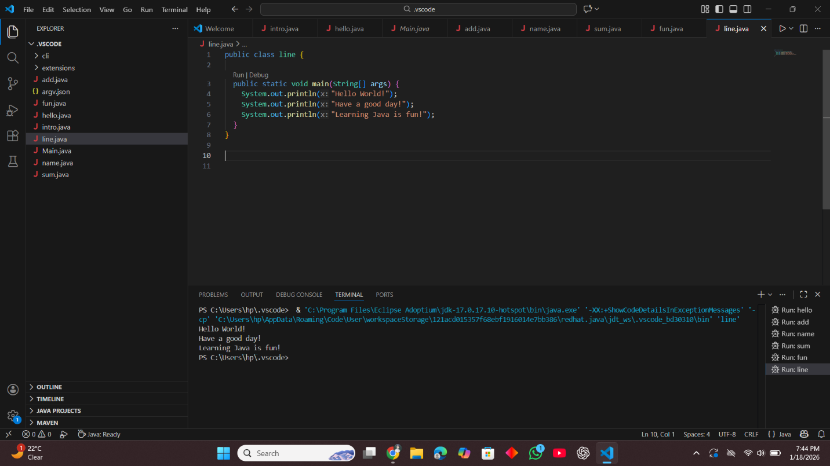
This code prints three separate messages, each on its own line.
It uses System.out.println() to move to a new line after each message.

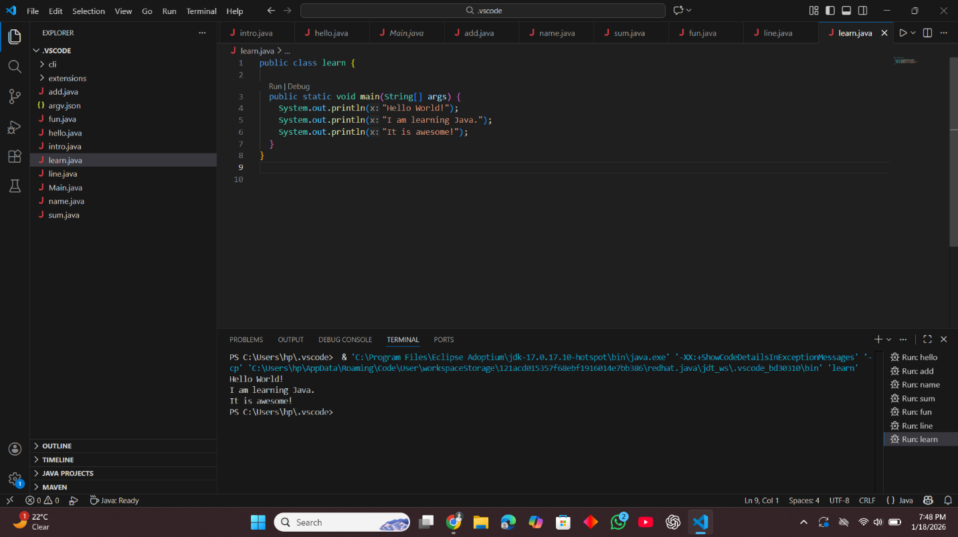
This code prints three messages about learning Java, each on a new line.
It uses System.out.println() to display each sentence separately.

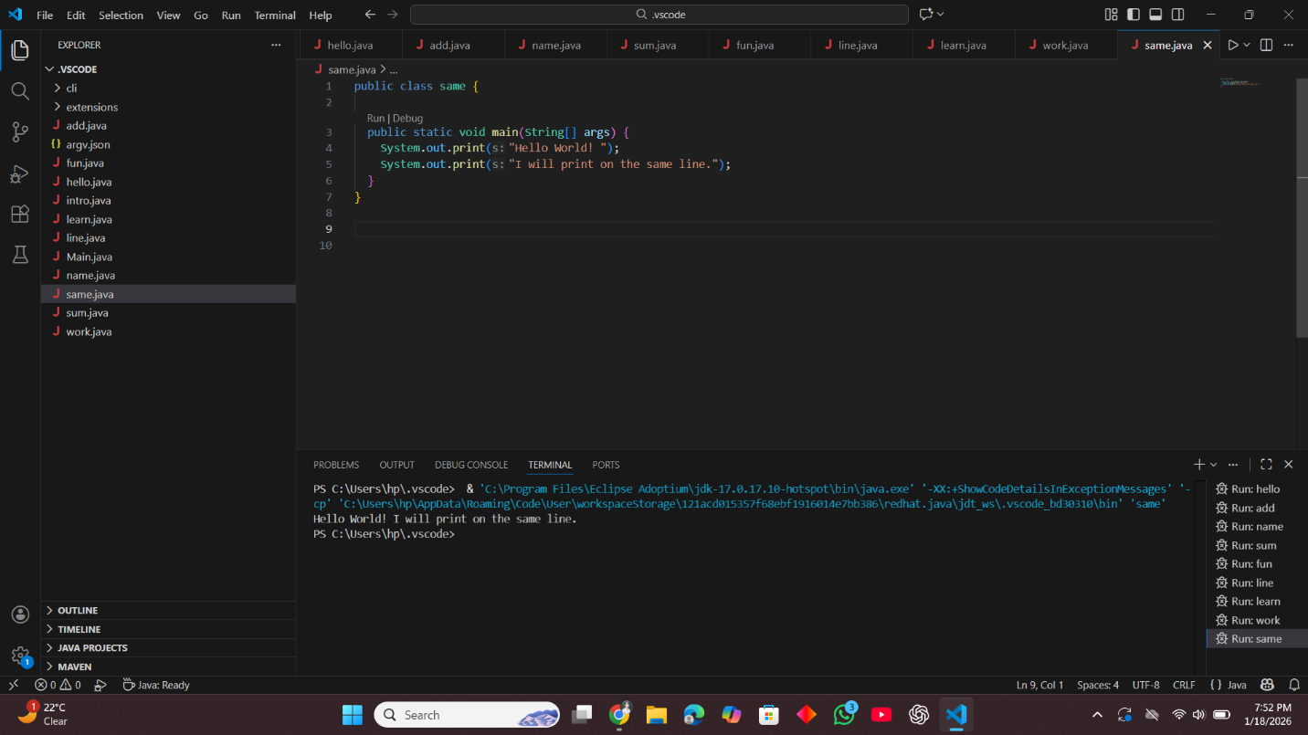

This code uses System.out.print() to display text without moving to a new line.
As a result, both messages are printed on the same line one after another.

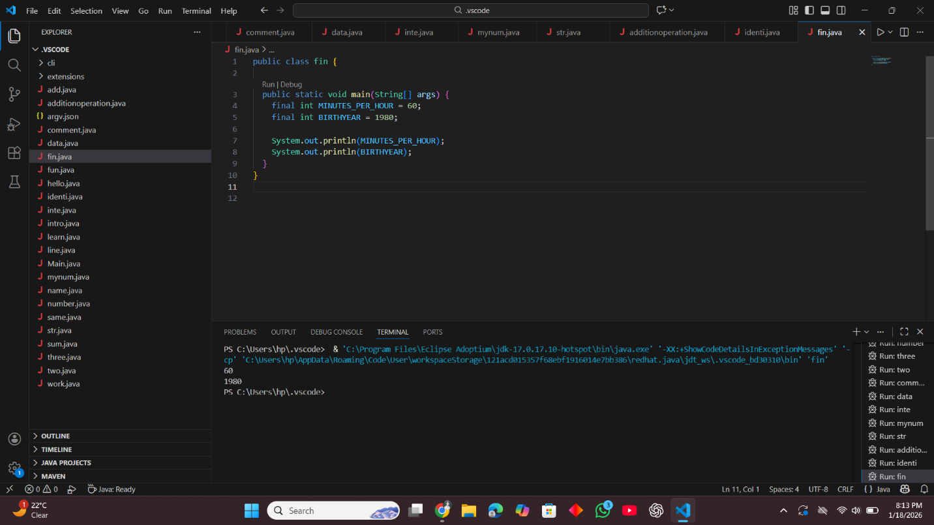
This code declares two constant values using final so they cannot be changed.
It then prints 60 and 1980 to the console.

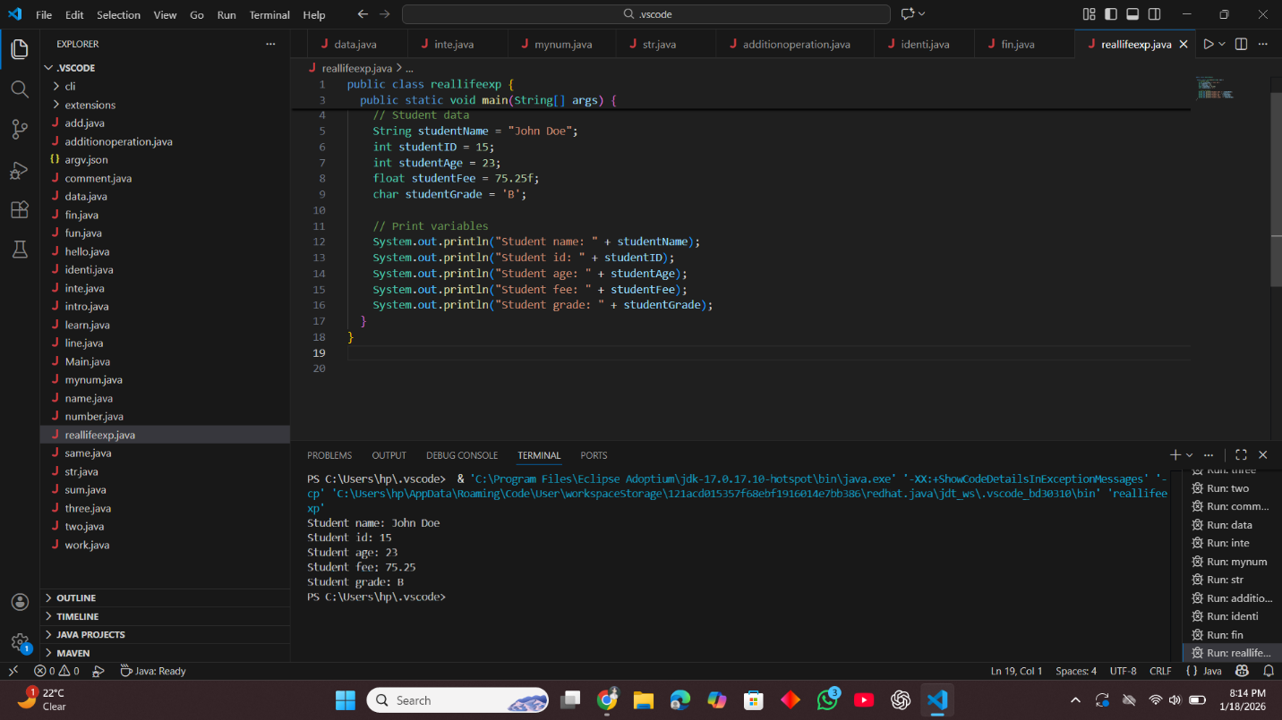
This code stores real-life student information using different data types.
It then prints each detail to the console in a readable format.

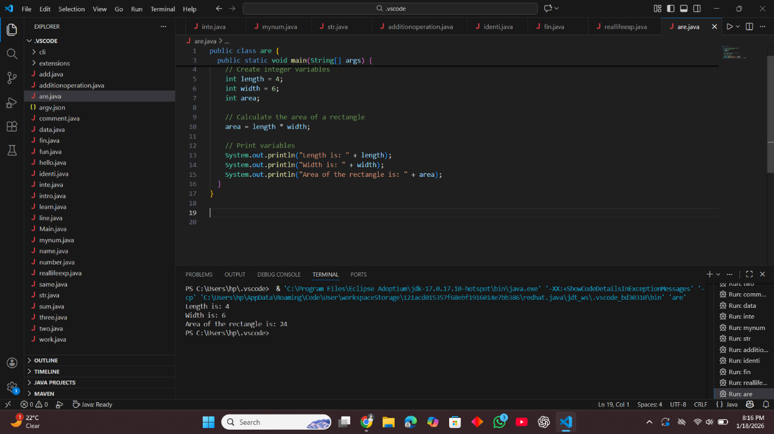

This code calculates the area of a rectangle by multiplying length and width.
It then prints the length, width, and the calculated area to the console.

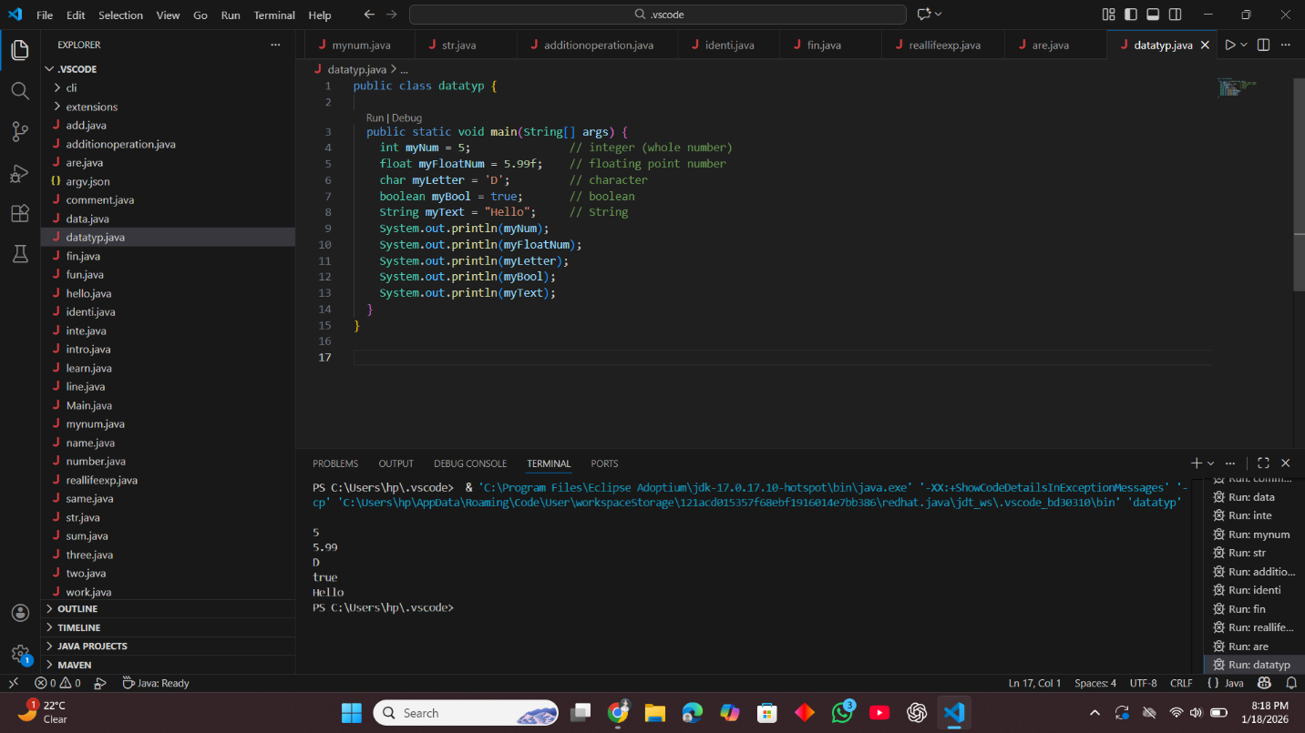

This code demonstrates different Java data types: int, float, char, boolean, and String.
It prints the value of each variable to the console.

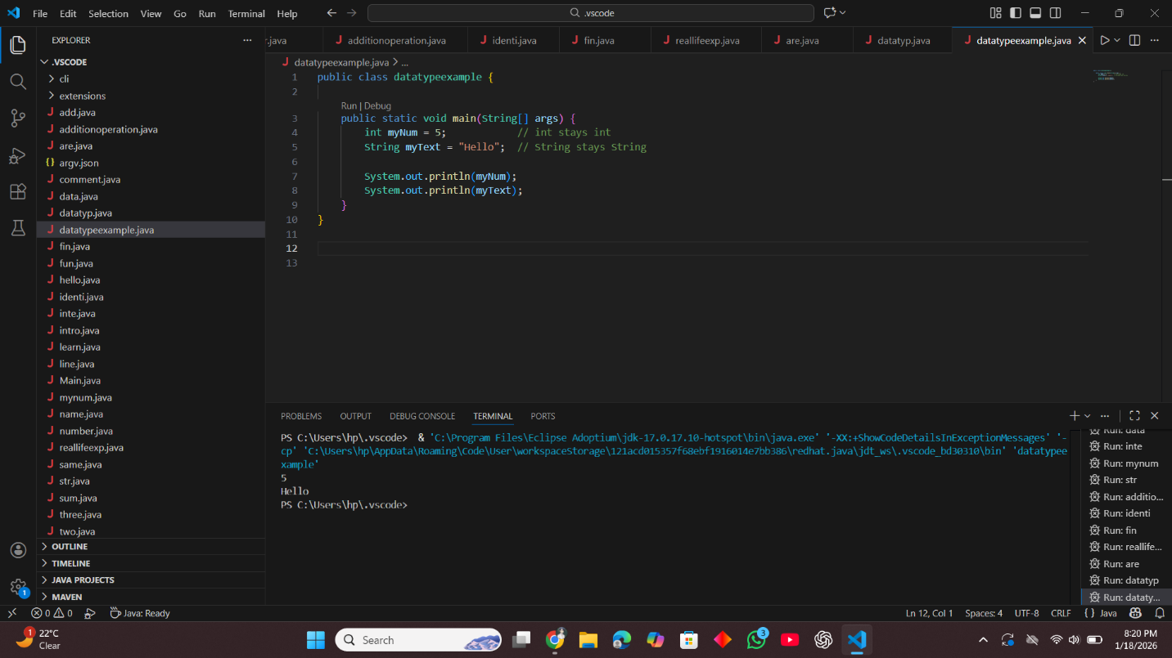

This code shows a simple example of Java data types.
It declares an int and a String, then prints 5 and Hello to the console.

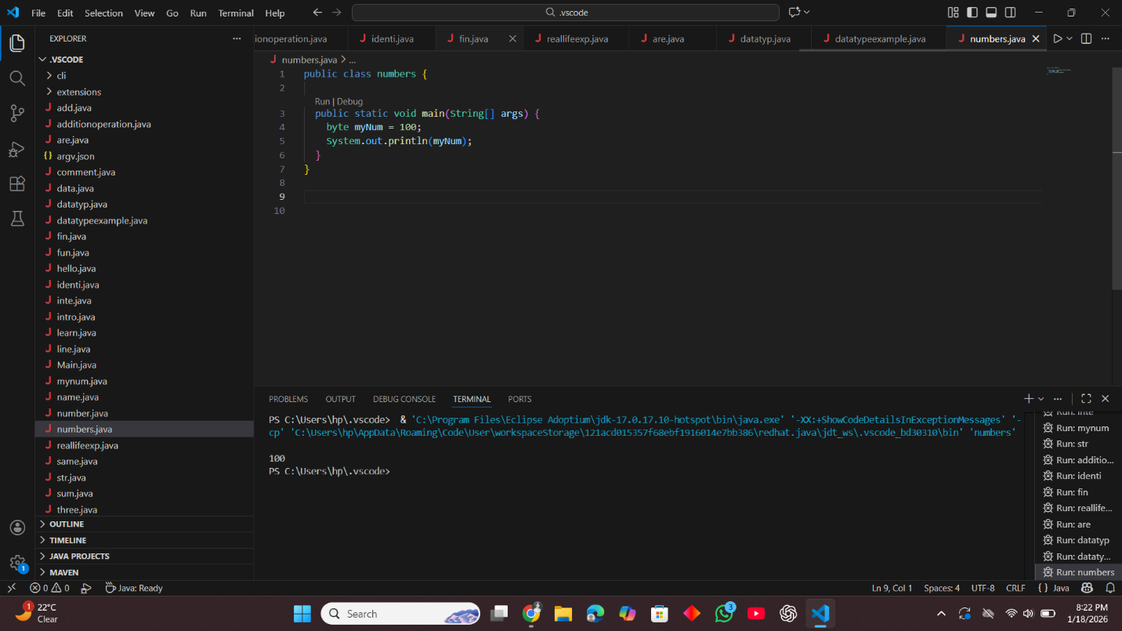
This code declares a byte variable myNum with the value 100.
It then prints 100 to the console.

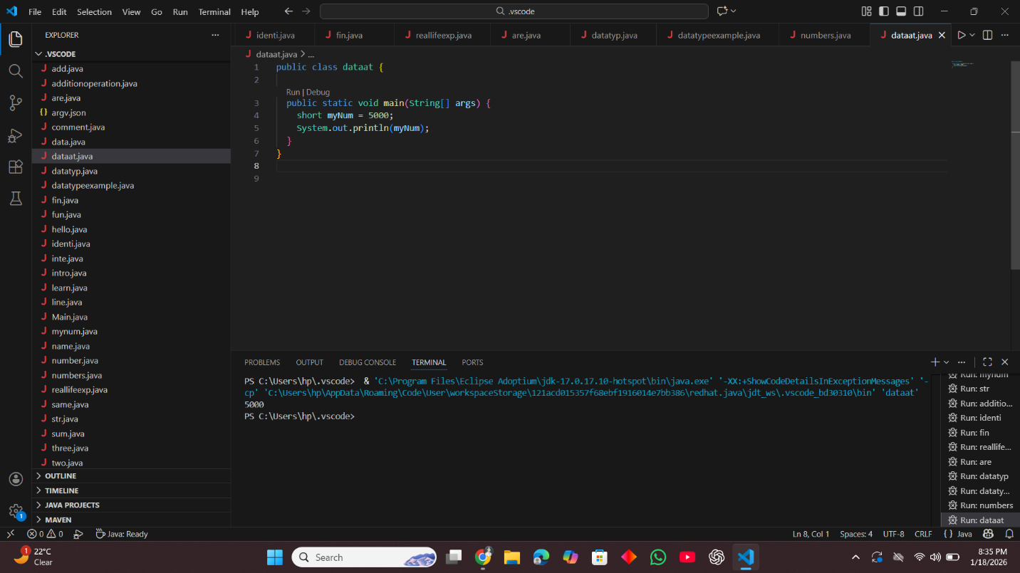
This code declares a short variable myNum with the value 5000.
It then prints 5000 to the console.

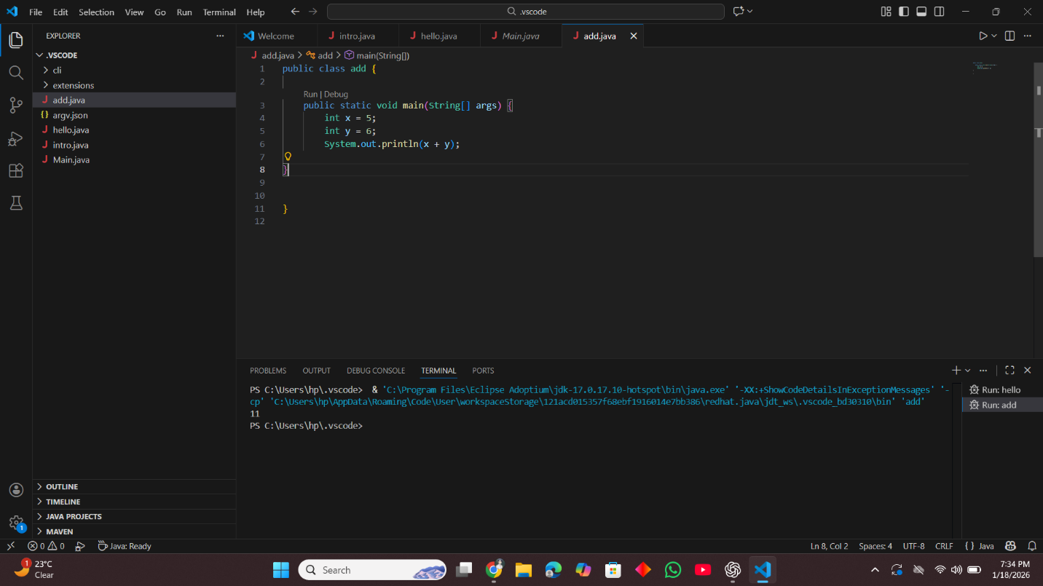
This code calculates the area of a rectangle by multiplying length and width.
It then prints the length, width, and the calculated area, which is 24, to the console.

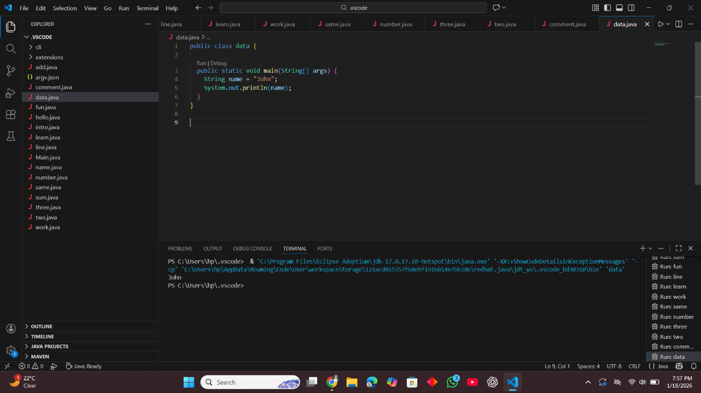
This code stores a name in a String variable and prints it.
It displays John on the console.

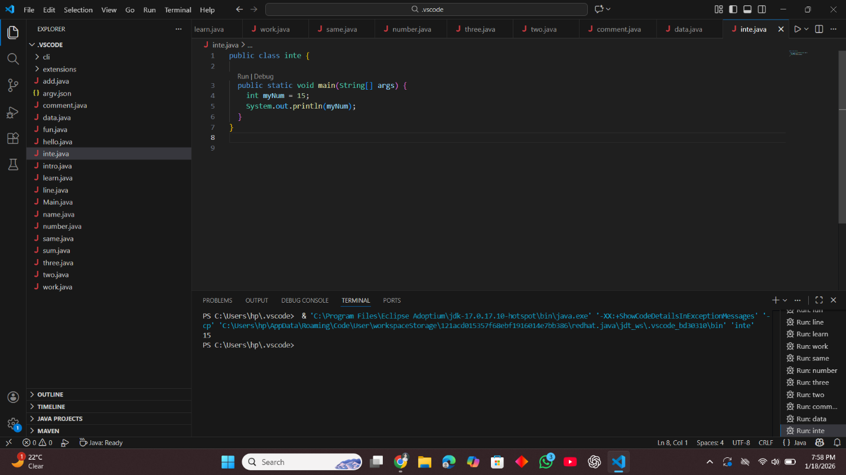
This code declares an integer variable myNum with the value 15.
It then prints 15 to the console.

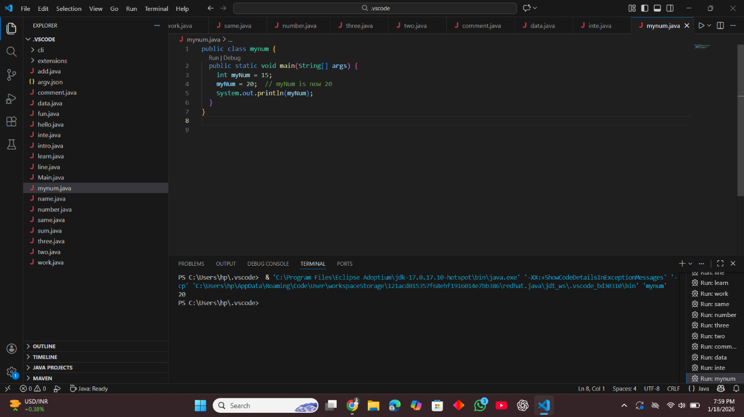
This code shows how to change the value of an int variable.
It first sets myNum to 15, updates it to 20, and then prints 20.

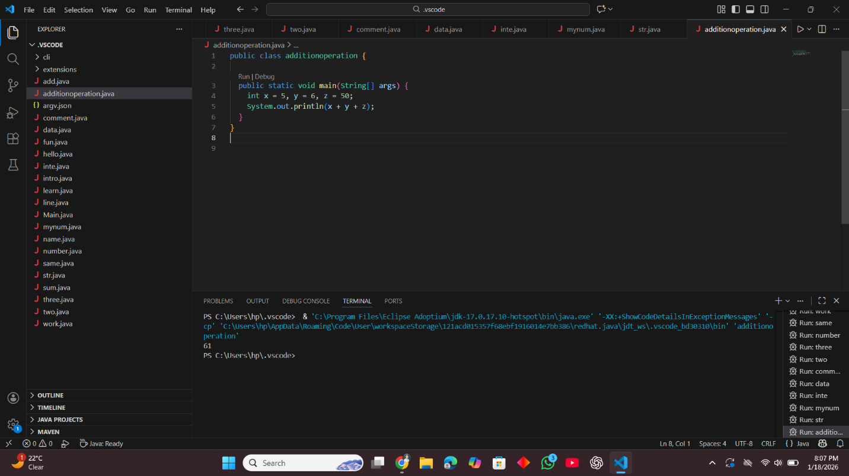
This code adds three integer values: x, y, and z.
It calculates 5 + 6 + 50 and prints 61 to the console.
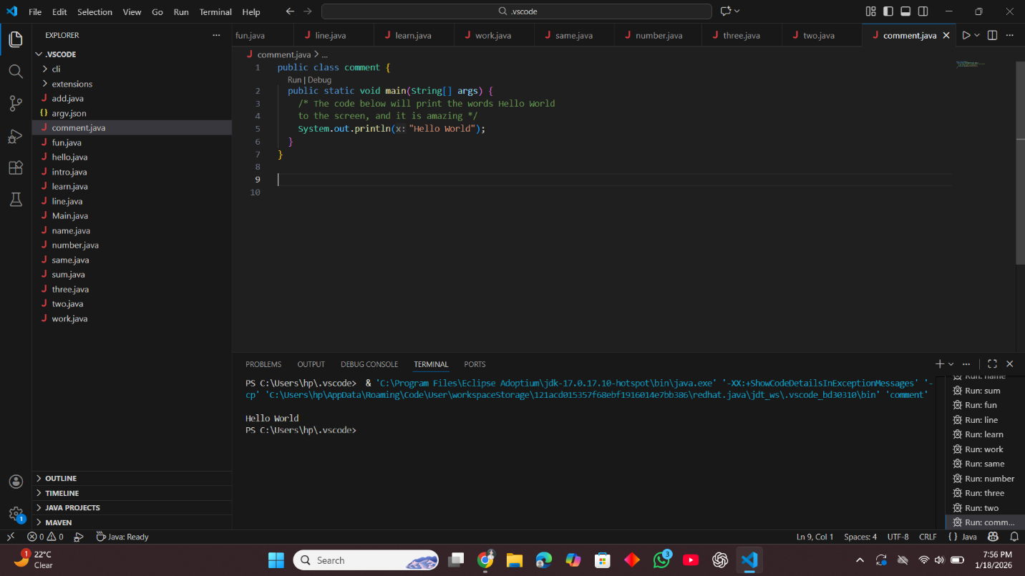
This code uses a multi-line comment to explain what it does.
It then prints "Hello World" to the console.

Lab Task :04
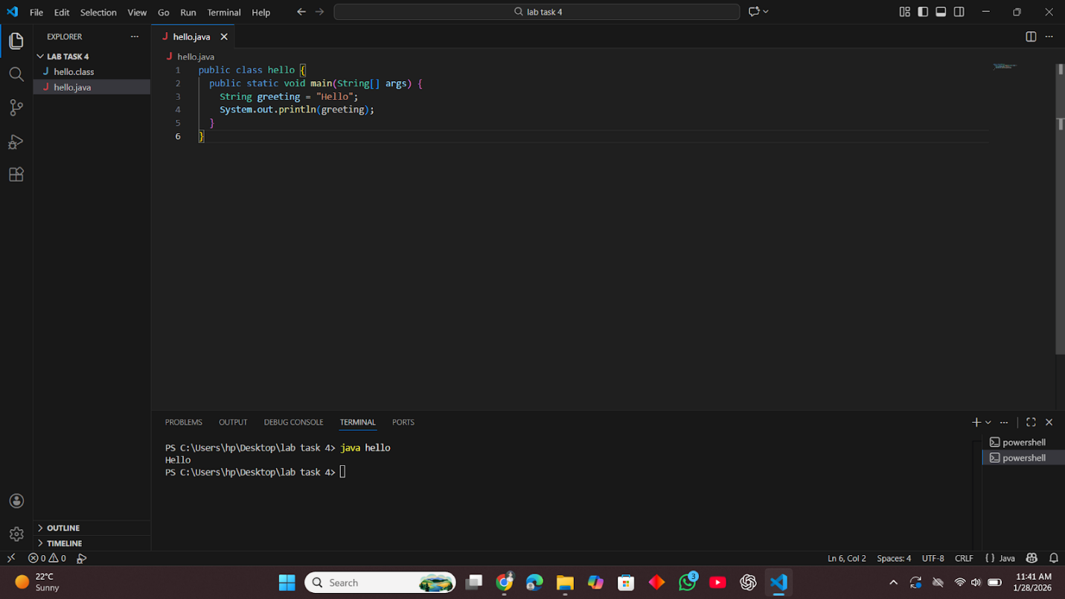

This is a code of printing a word.
It stores "Hello" in a variable and shows it on the screen.
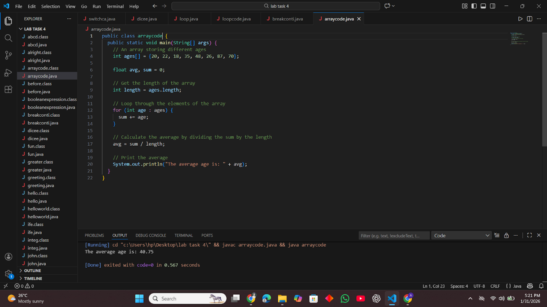
This is a code of finding an average.
It adds all the numbers in the array and divides the sum by the total count.
Then it prints the average value on the screen.
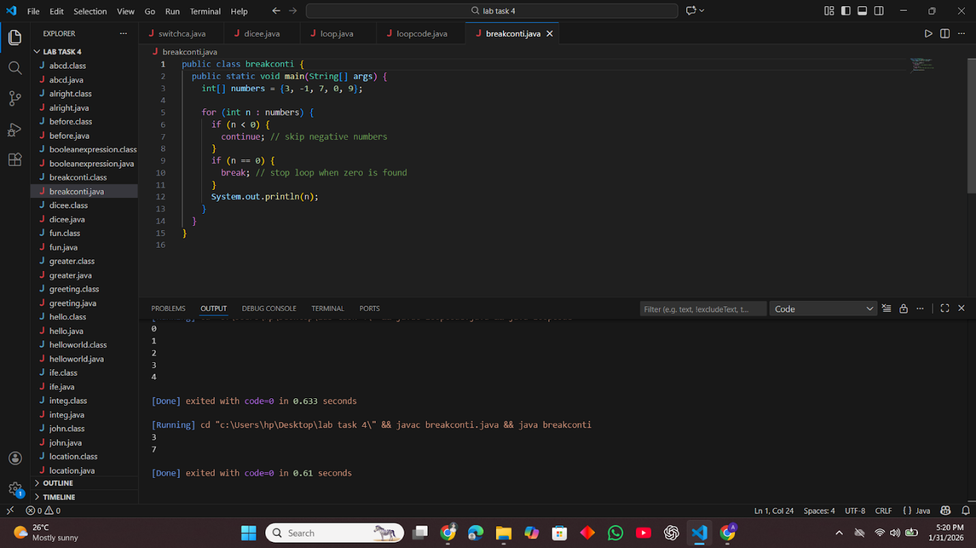
This is a code of loop control.
It skips negative numbers, stops when zero is found, and prints only the valid numbers.
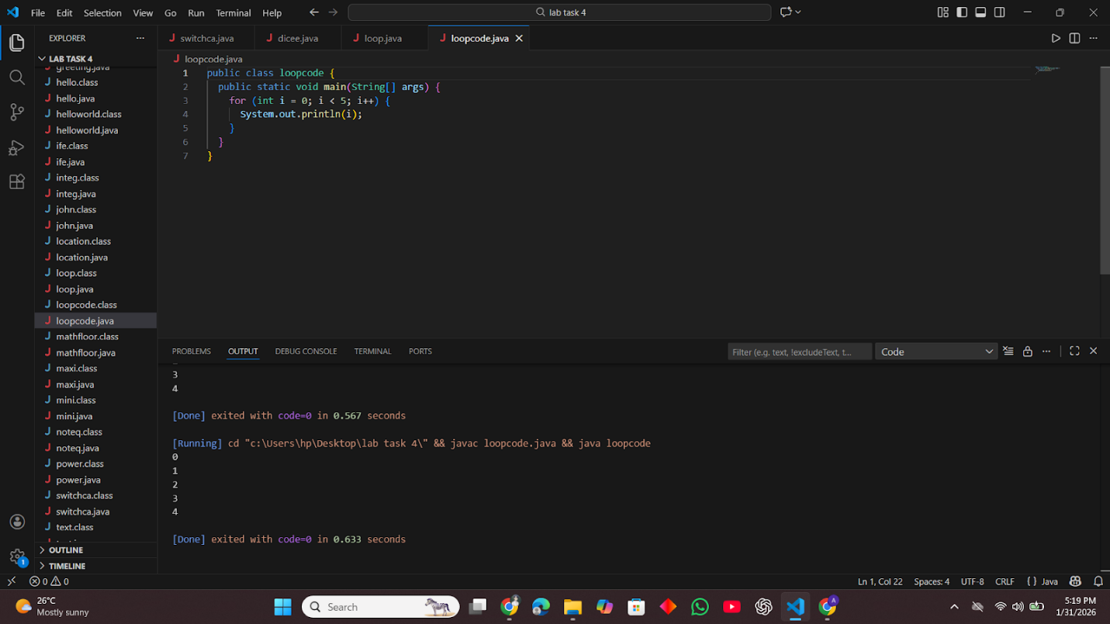
This is a code of repeating numbers.
It runs a loop from 0 to 4 and prints each number on the screen.
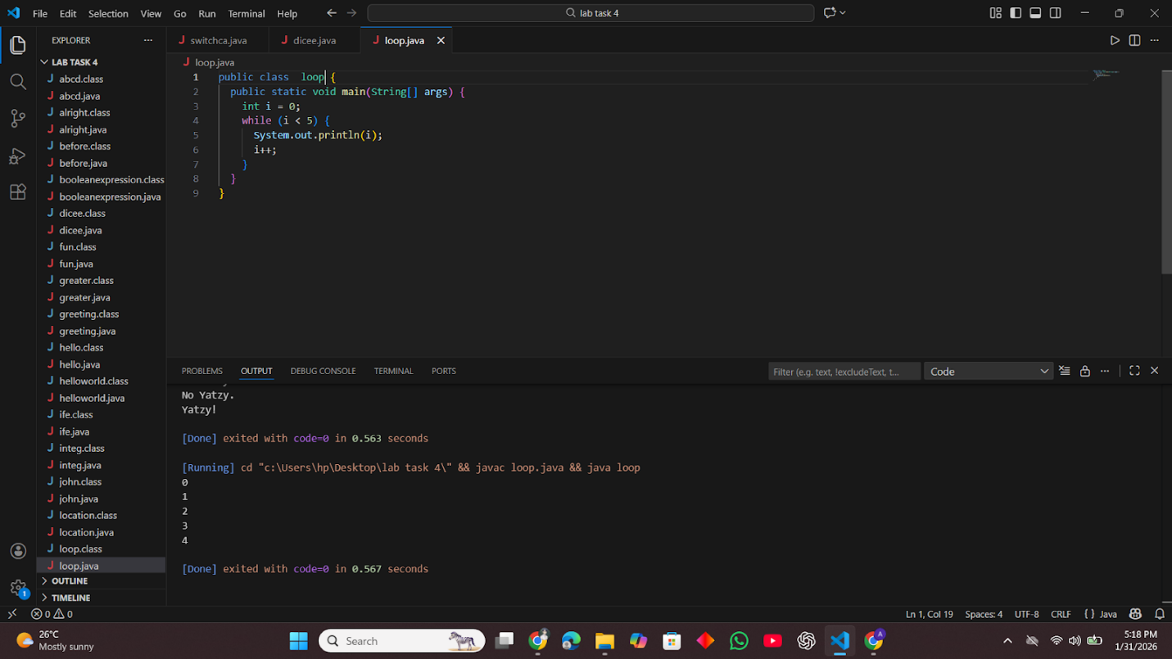
This is a code of printing numbers using a loop.
It keeps running while the value is less than 5 and prints each number.
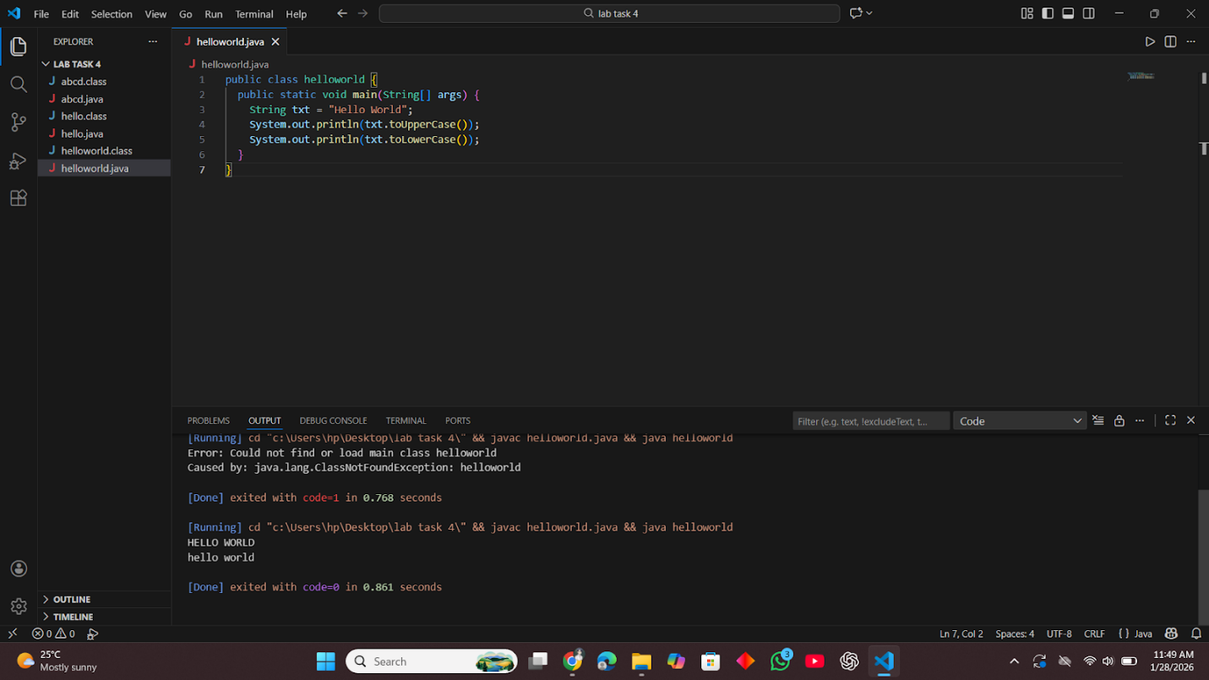
This is a code of changing text format.
It converts the text to uppercase and lowercase and prints both on the screen.
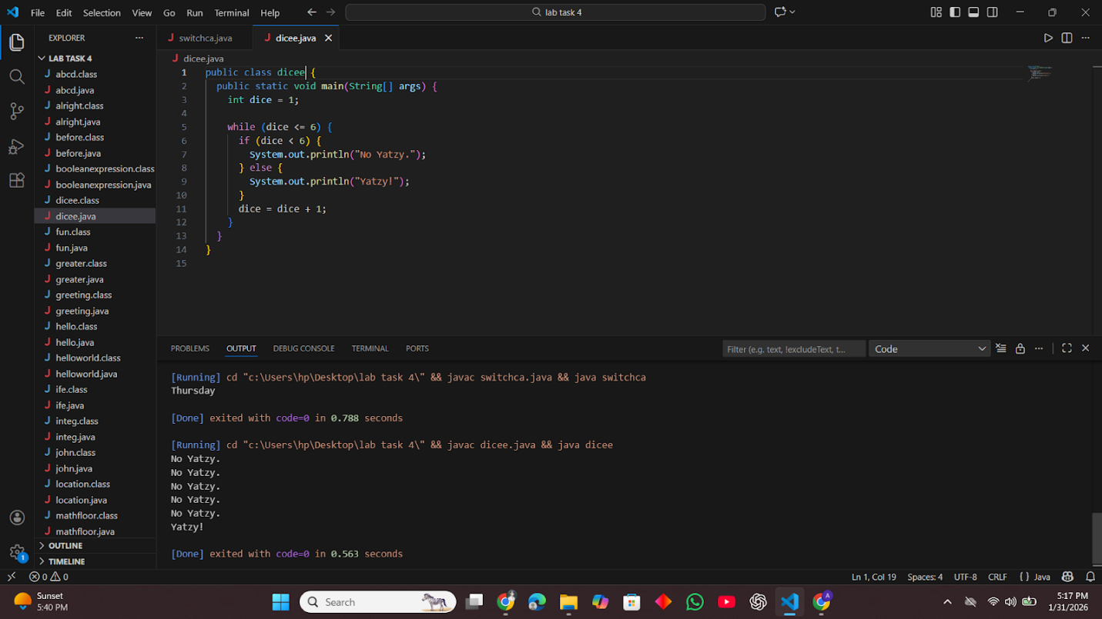
This is a code of checking a condition in a loop.
It increases a number from 1 to 6 and prints “No Yatzy” until 6, then prints “Yatzy!”.

This is a code of finding an average.
It adds all the numbers in the array and divides the sum by the total count.
Then it prints the average value on the screen.
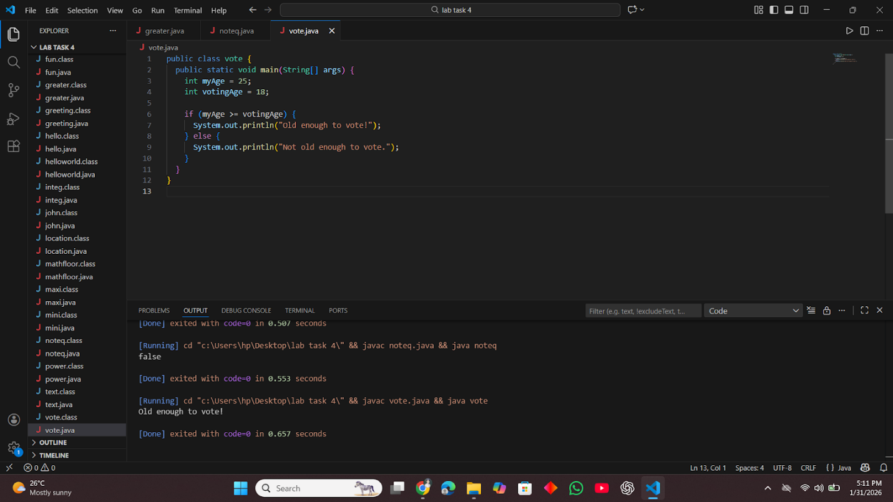
This is a code of age checking.
It compares two values and checks if the age is enough for voting.
Then it prints the result on the screen.
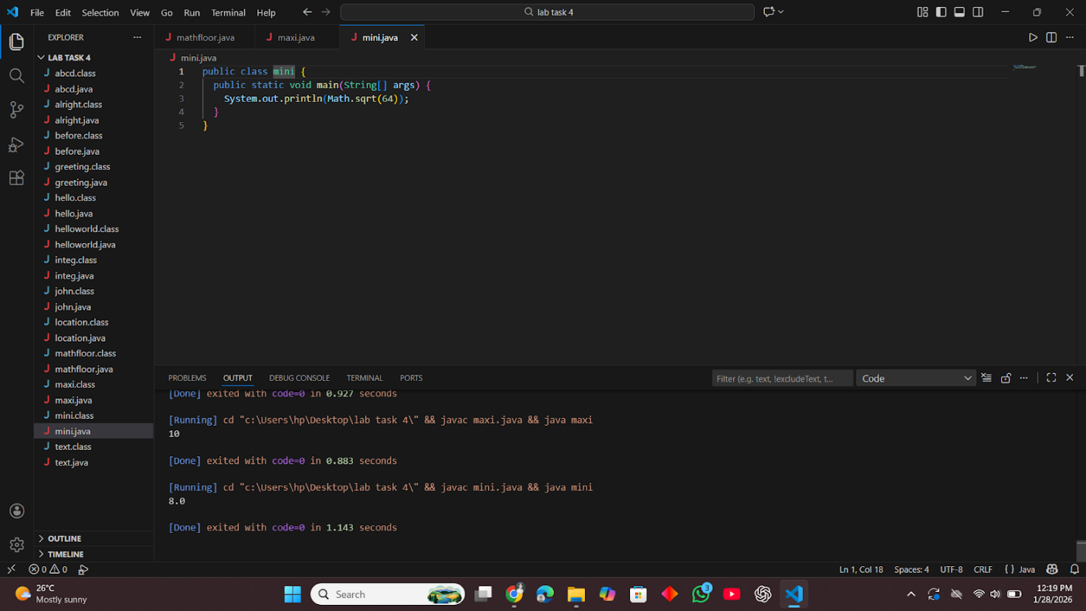
This is a code of finding a square root.
It calculates the square root of 64 and prints the result on the screen.
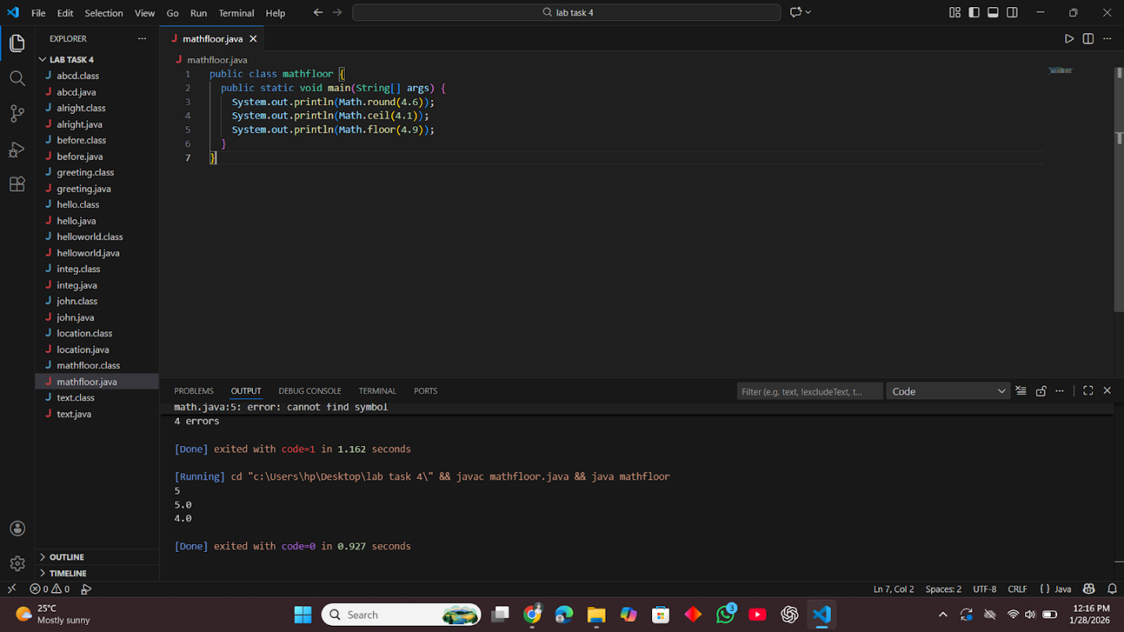
This is a code of rounding numbers.
It shows round, ceil, and floor values of numbers and prints the results.
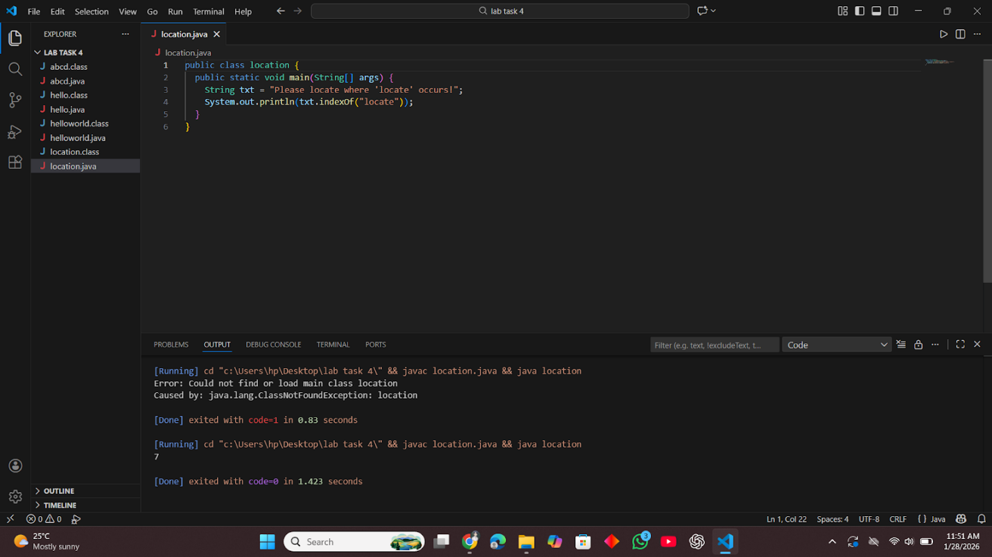
This is a code of finding word position.
It searches for a word in a text and prints its starting index number.
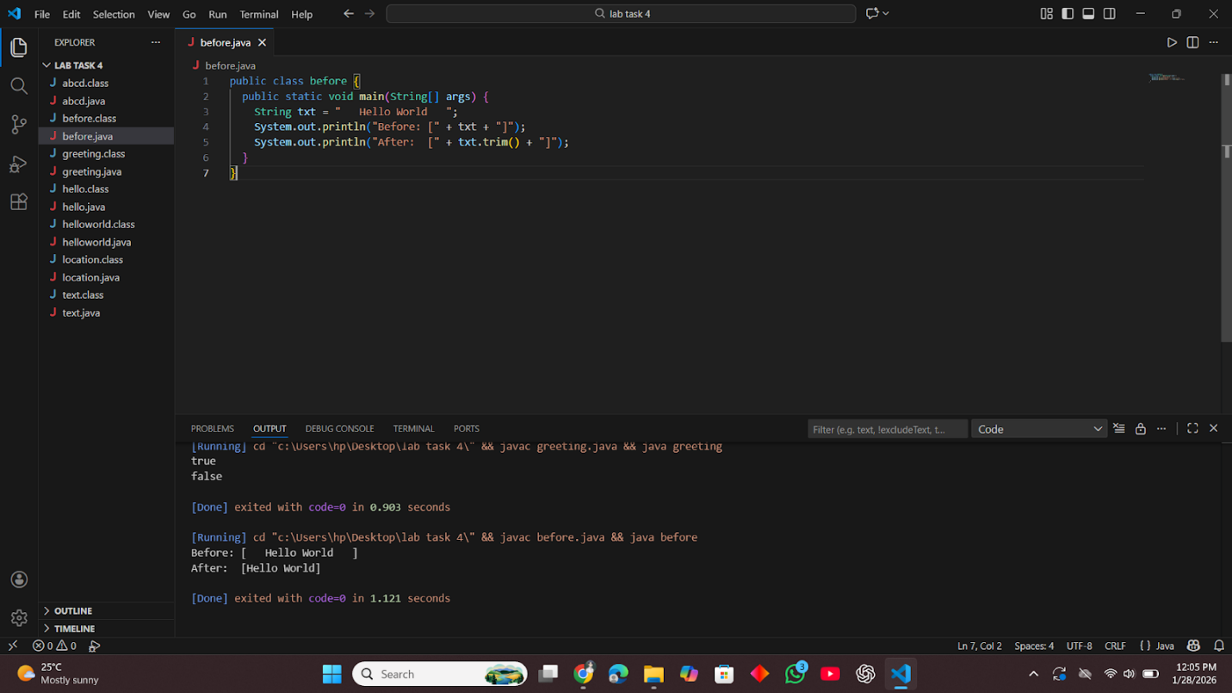
This is a code of removing extra spaces.
It trims the spaces before and after the text and prints both versions.
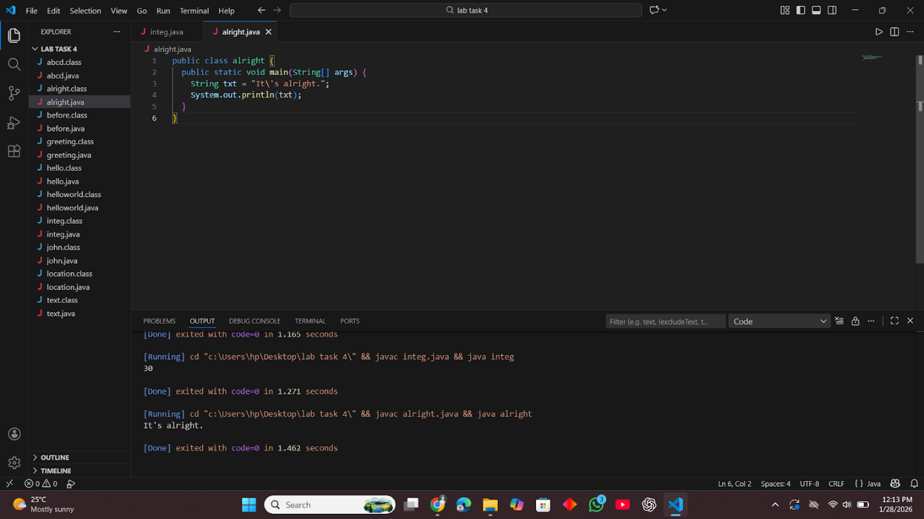
This is a code of printing special characters.
It uses an escape character to print a sentence with an apostrophe correctly.
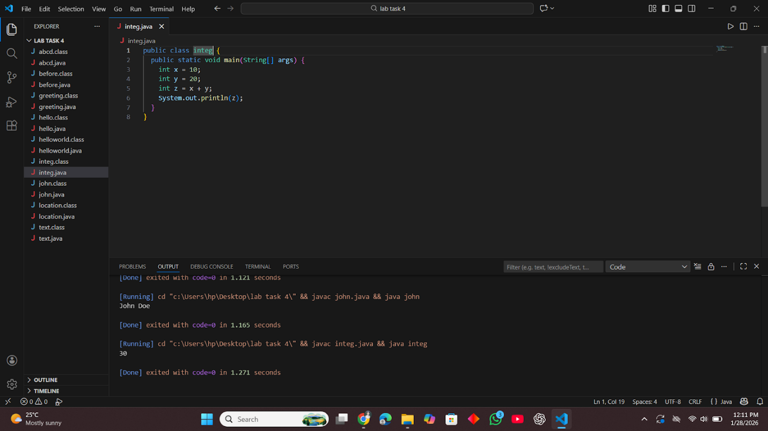
This is a code of adding two numbers.
It adds two values and prints the result on the screen.

Lab Task :05

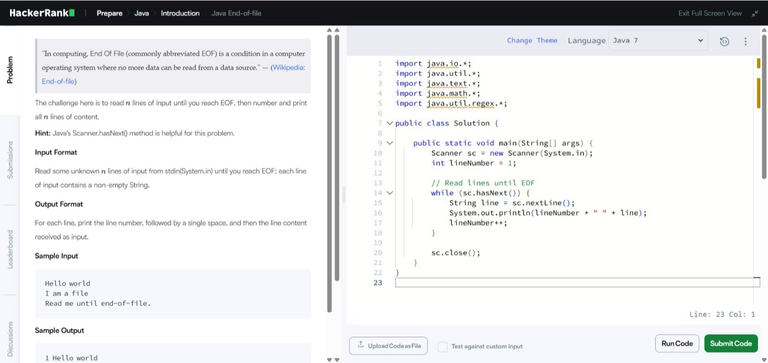
This is the Java End-of-file problem solution.
The code reads all input lines one by one until there is no more data (end of file), assigns a number starting from 1 to each line, and prints them in the format "number space line-text" (e.g., "1 Hello world"). It uses a while loop with sc.hasNext() to check for more input and sc.nextLine() to read each full line safely.
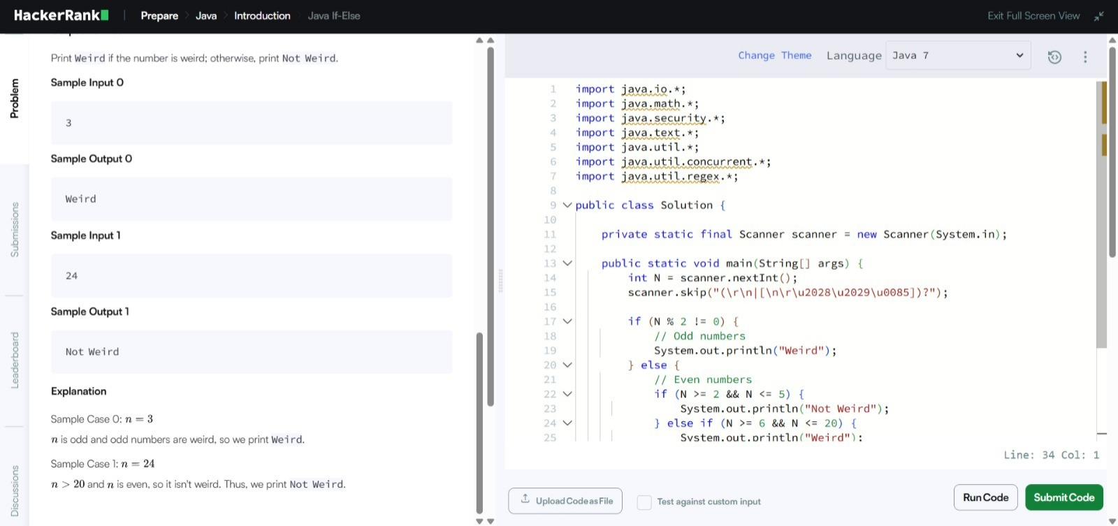
This is the Java If-Else problem solution.
The code reads one integer N from input and uses if-else conditions to decide:
If N is odd, print "Weird"
If N is even: print "Not Weird" if N is 2–5 or greater than 20; print "Weird" if N is 6–20.
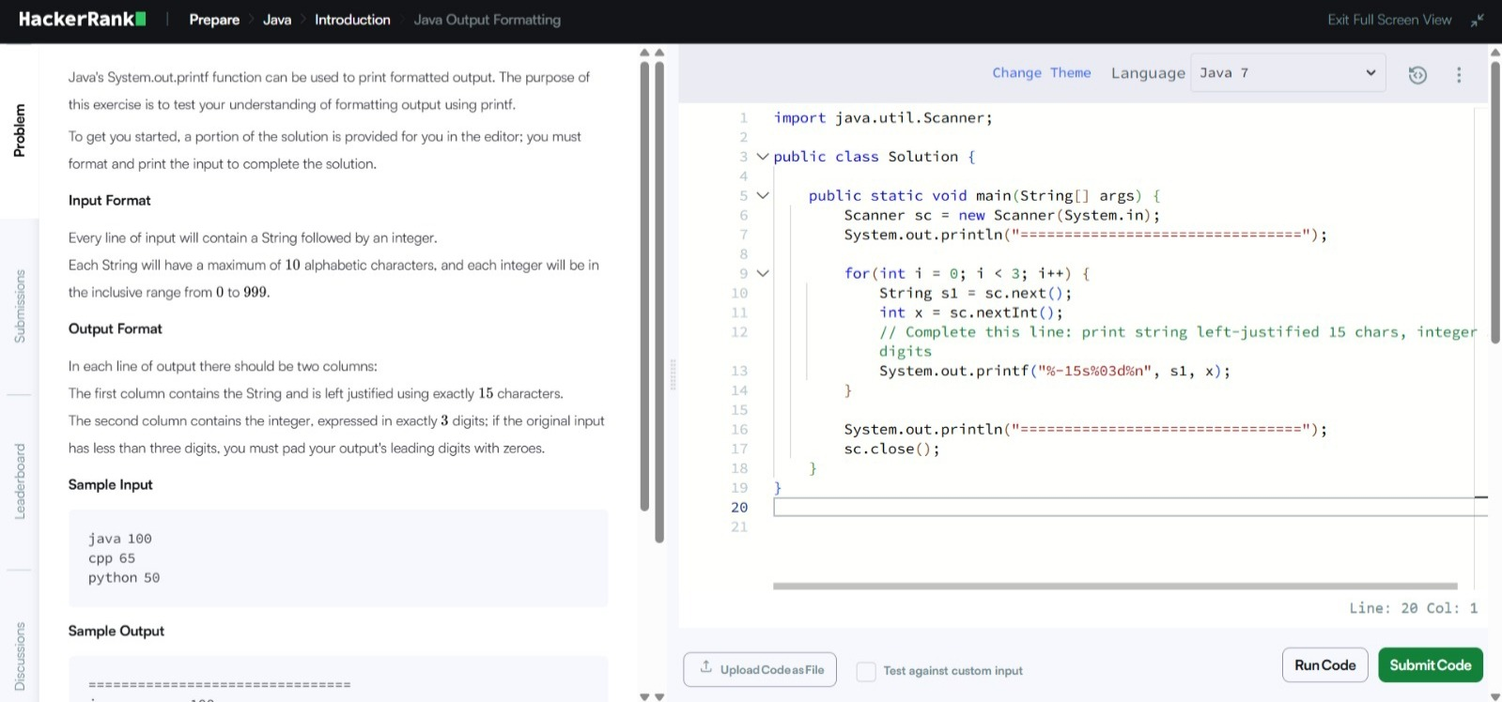
The string is left-aligned in exactly 15 characters (using %-15s).
The integer is shown as exactly 3 digits with leading zeros if needed (using %03d).
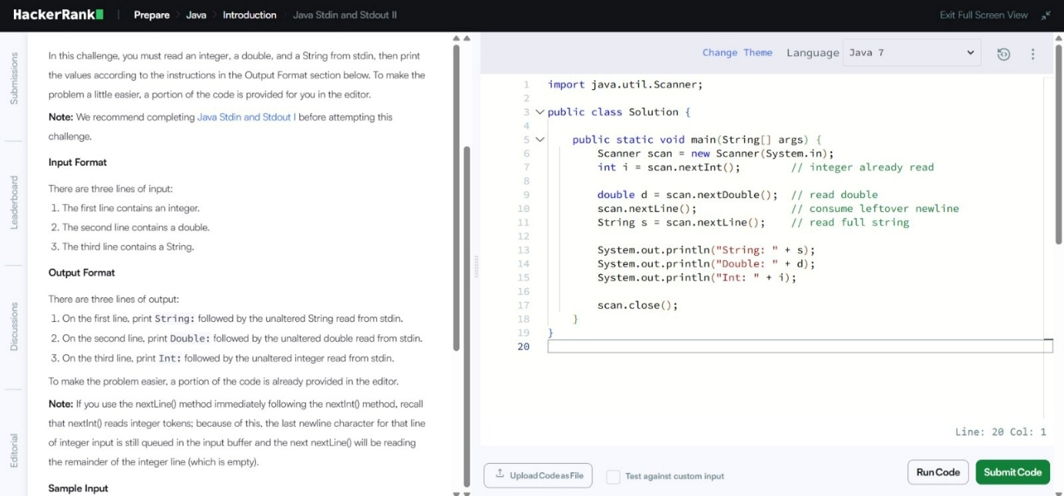
The code reads three values from input in this order:
an integer (using nextInt())
a double (using nextDouble())
a full String (using nextLine() after consuming the leftover newline with an extra nextLine()).
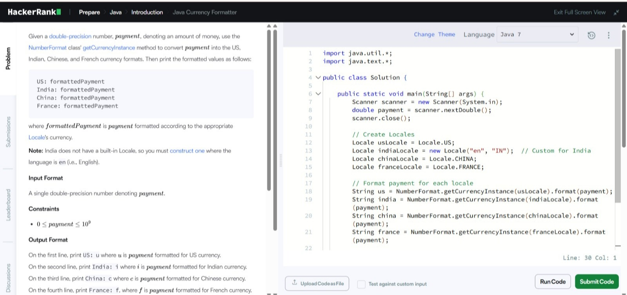
The code reads a double value payment (an amount of money) from input, then formats and prints it in four different currency styles using NumberFormat.getCurrencyInstance(Locale):
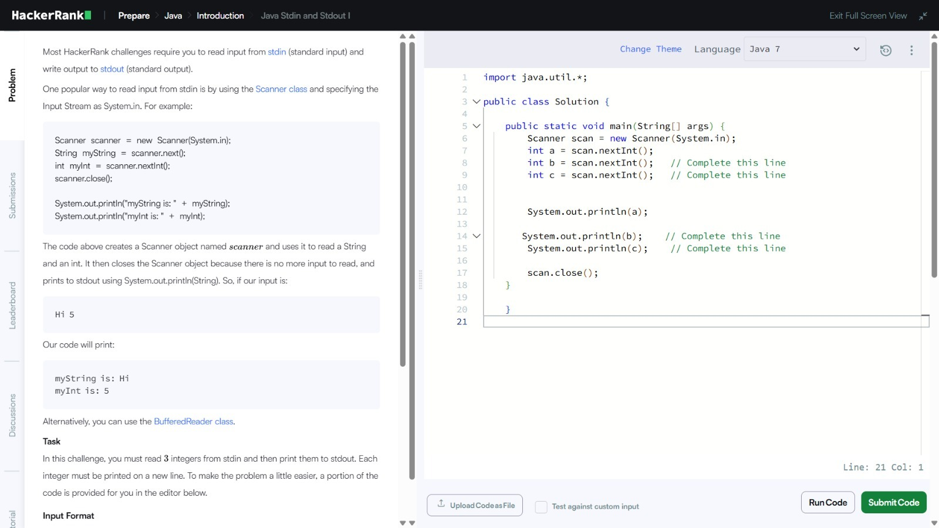
The code reads three integers from input (one per line or separated by spaces) using Scanner methods nextInt() three times, stores them in variables a, b, and c, then prints each integer on its own new line using System.out.println().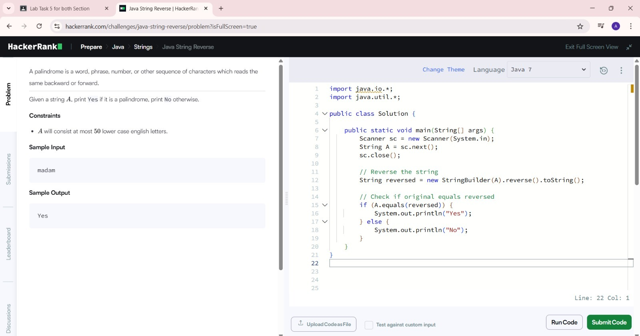
The code reads a single lowercase string A from input, reverses it using StringBuilder(A).reverse().toString(), then checks if the original string equals the reversed version using equals().
If they match (it's a palindrome like "madam"), it prints "Yes"; otherwise, it prints "No".
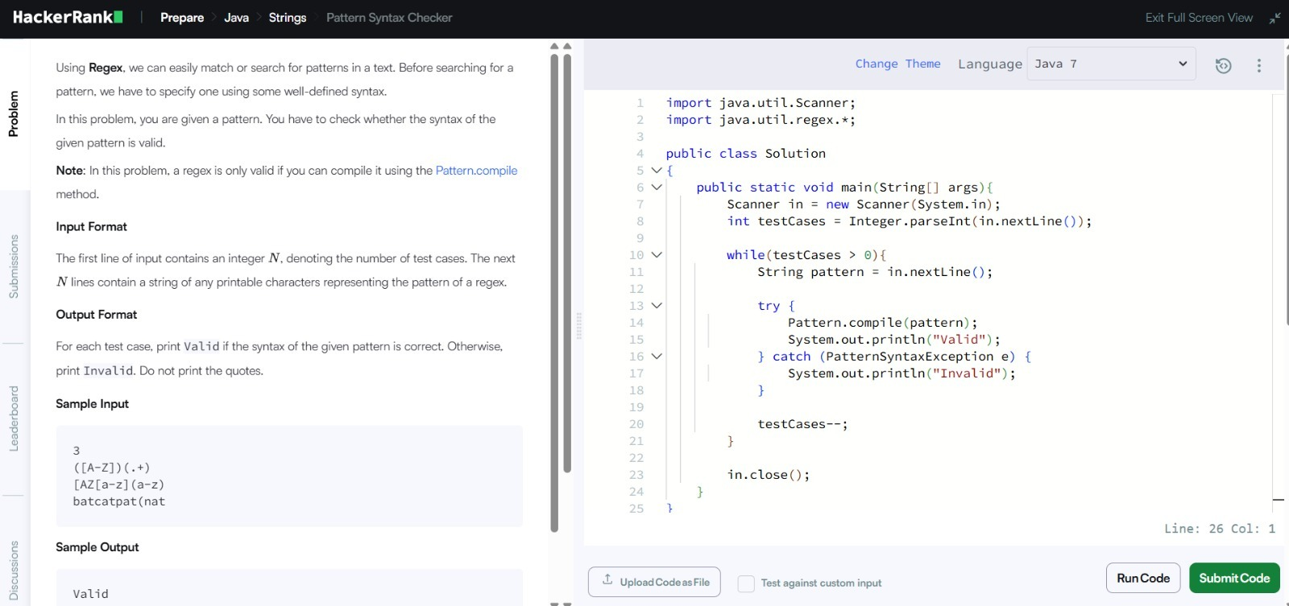
The code reads an integer N (number of test cases), then reads N regex pattern strings. For each pattern, it tries to compile it using Pattern.compile(pattern).
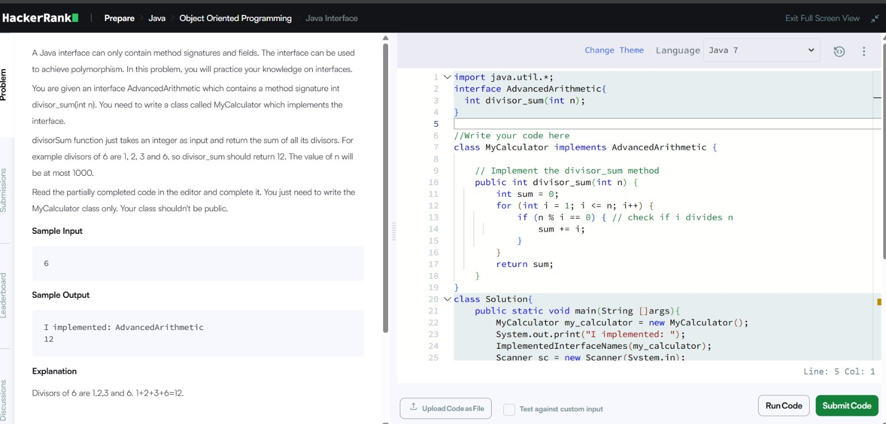
The code defines a class MyCalculator that implements the AdvancedArithmetic interface by providing the divisor_sum(int n) method, which calculates and returns the sum of all divisors of n (e.g., for n=6, divisors are 1+2+3+6 = 12).
It uses a simple for loop from 1 to n to check which numbers divide n evenly (n % i == 0) and adds them to a sum variable.
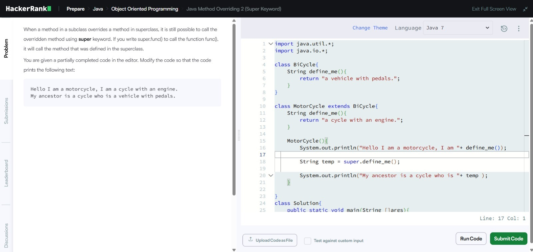
The code overrides the define_me() method in the MotorCycle subclass (which extends BiCycle), so when called on a MotorCycle object, it returns "a cycle with an engine.”
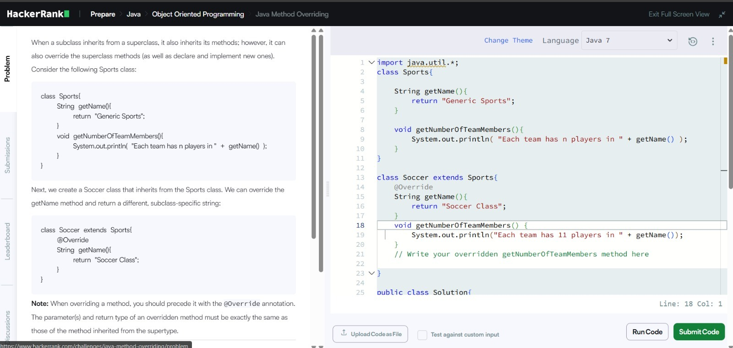
The code creates a Soccer class that extends Sports and overrides two methods:
getName() to return "Soccer Class" instead of the parent's "Generic Sports"
getNumberOfTeamMembers() to print "Each team has 11 players in Soccer Class" (overriding the parent's generic message that uses 'n' players)
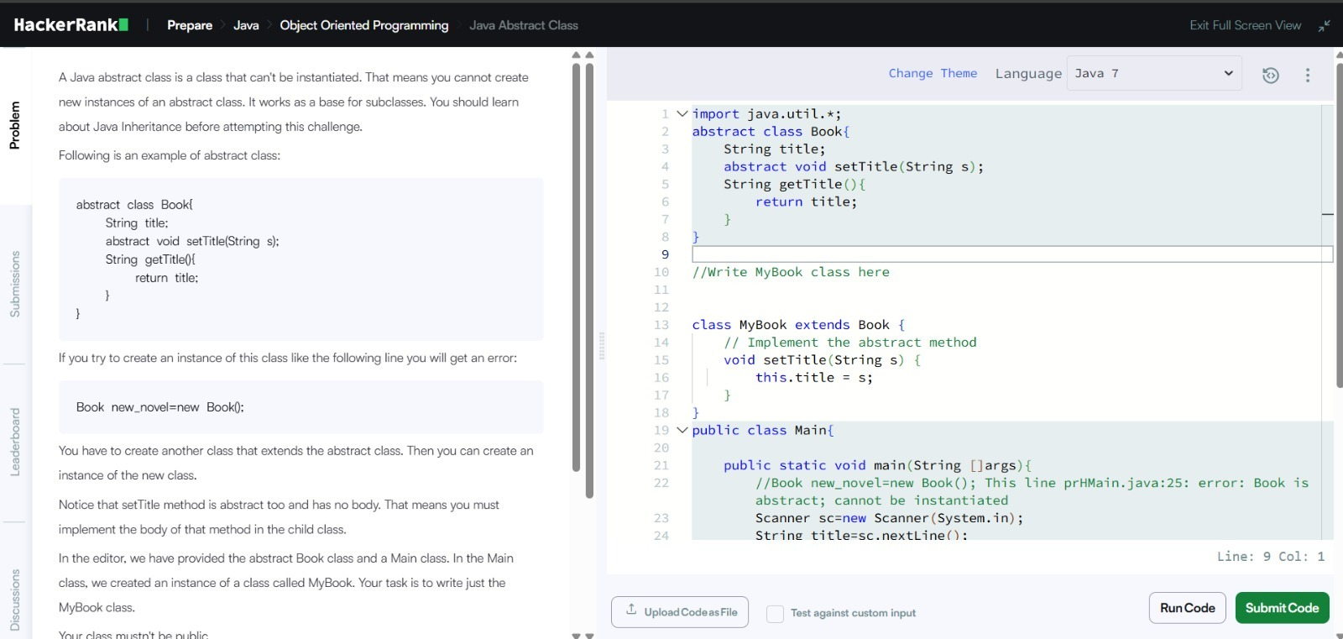
The code creates a concrete class MyBook that extends the abstract class Book.
It implements (provides the body for) the abstract method setTitle(String s) by setting this.title = s;, allowing you to create objects of MyBook (but not of Book itself, since abstract classes cannot be instantiated).
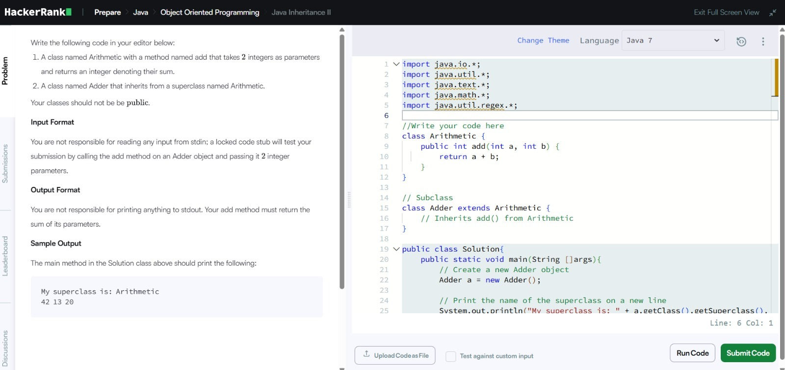
The code defines two classes:
Arithimetic with a method add(int a, int b) that returns the sum of two integers (a + b).
Adder which extends (inherits from) Arithimetic, so it automatically gets the add() method without needing to rewrite it.
The solution shows basic inheritance: the subclass Adder reuses the parent's add() method to compute sums (like 13 + 20 + 9 = 42 in the sample), and the locked test code prints the superclass name using reflection (getClass().getSuperclass()) along with the result.
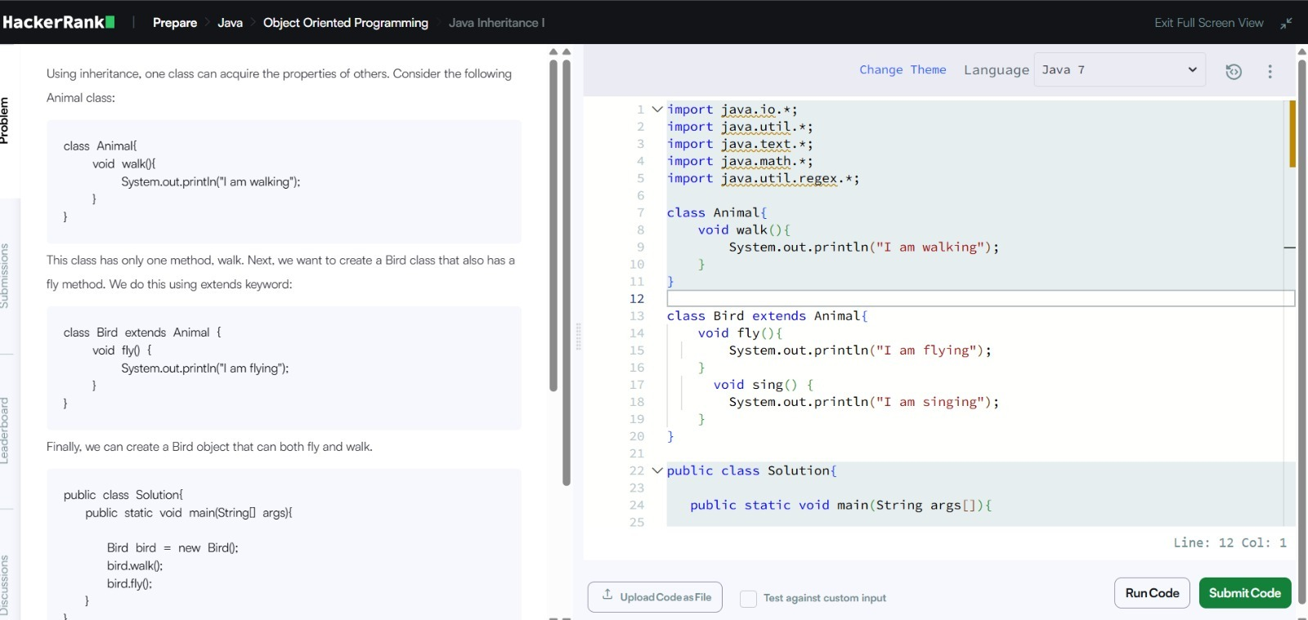
The code defines two non-public classes:
Arithimetic with a method add(int a, int b) that simply returns the sum of the two integers (a + b).
Adder which extends (inherits from) Arithimetic, so it automatically gets and can use the add() method without redefining it.
This demonstrates basic inheritance: the child class Adder reuses the parent's addition logic, and the locked test code creates an Adder object, calls add(), prints the result (e.g., 42 for some inputs), and shows the superclass name using reflection (getClass().getSuperclass().getName()).
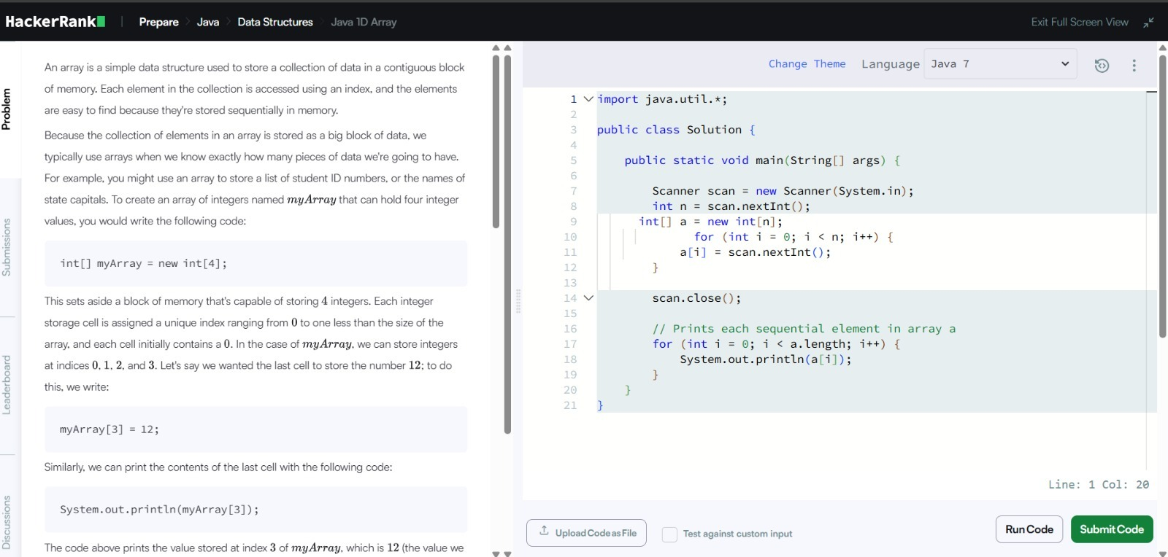
The code defines:
An Animal class with a walk() method that prints "I am walking".
A Bird class that extends (inherits from) Animal, so it gets walk() for free, and adds two new methods:
fly() → prints "I am flying"
sing() → prints "I am singing”
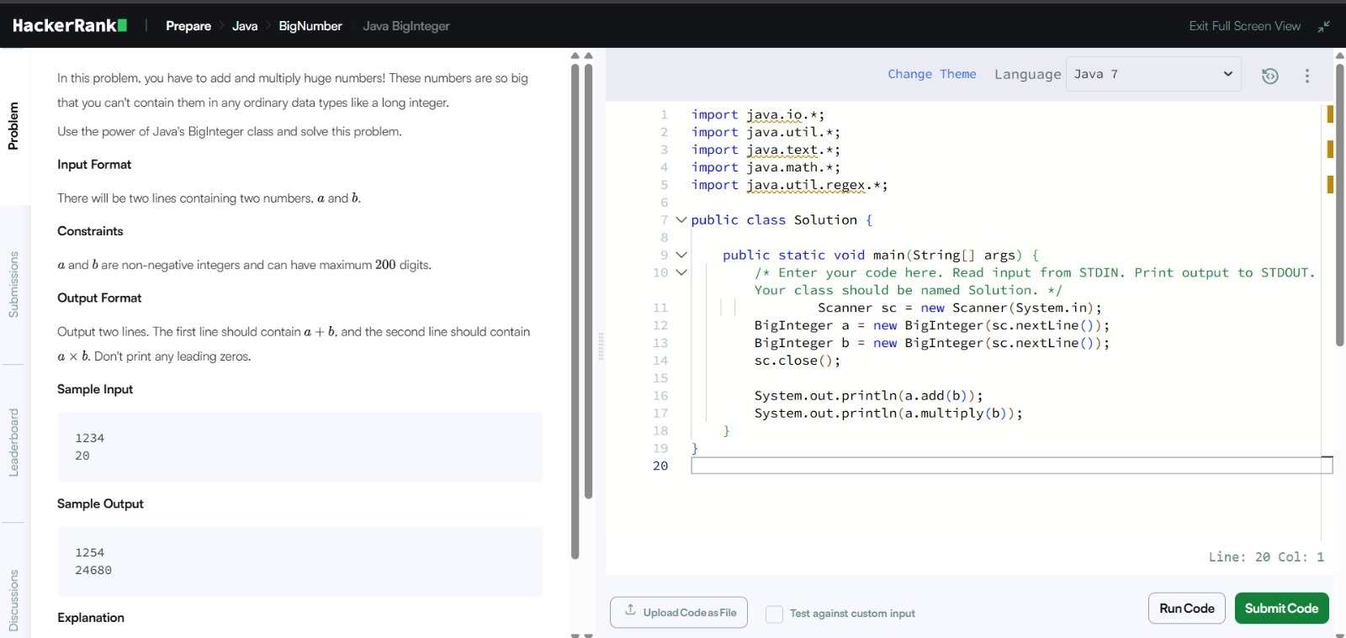
The code reads an integer n (size of the array), creates an integer array a of size n, then reads n integers from input and stores them in the array using a for loop. Finally, it prints each element of the array on a new line (one per index) using another for loop that iterates from 0 to a.length - 1.
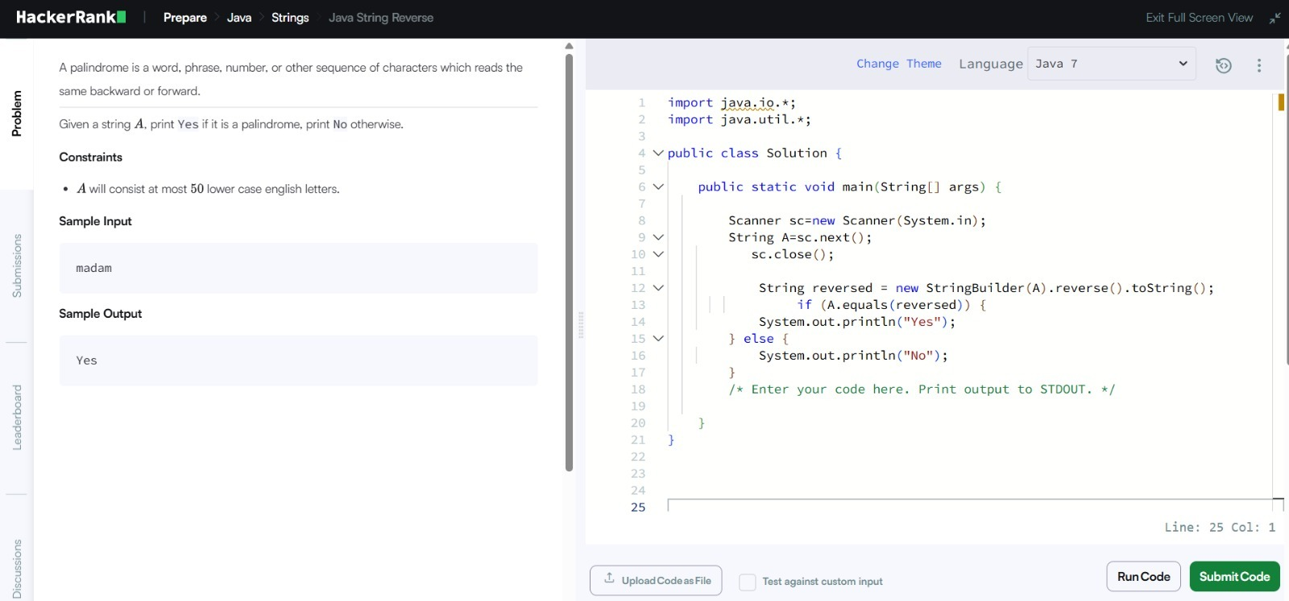
The code reads two very large non-negative integers (up to 200 digits each) as strings from input using Scanner.nextLine(), converts them into BigInteger objects (since normal int/long can't hold such big numbers), then:
Prints their sum using a.add(b) on the first line
Prints their product using a.multiply(b) on the second line
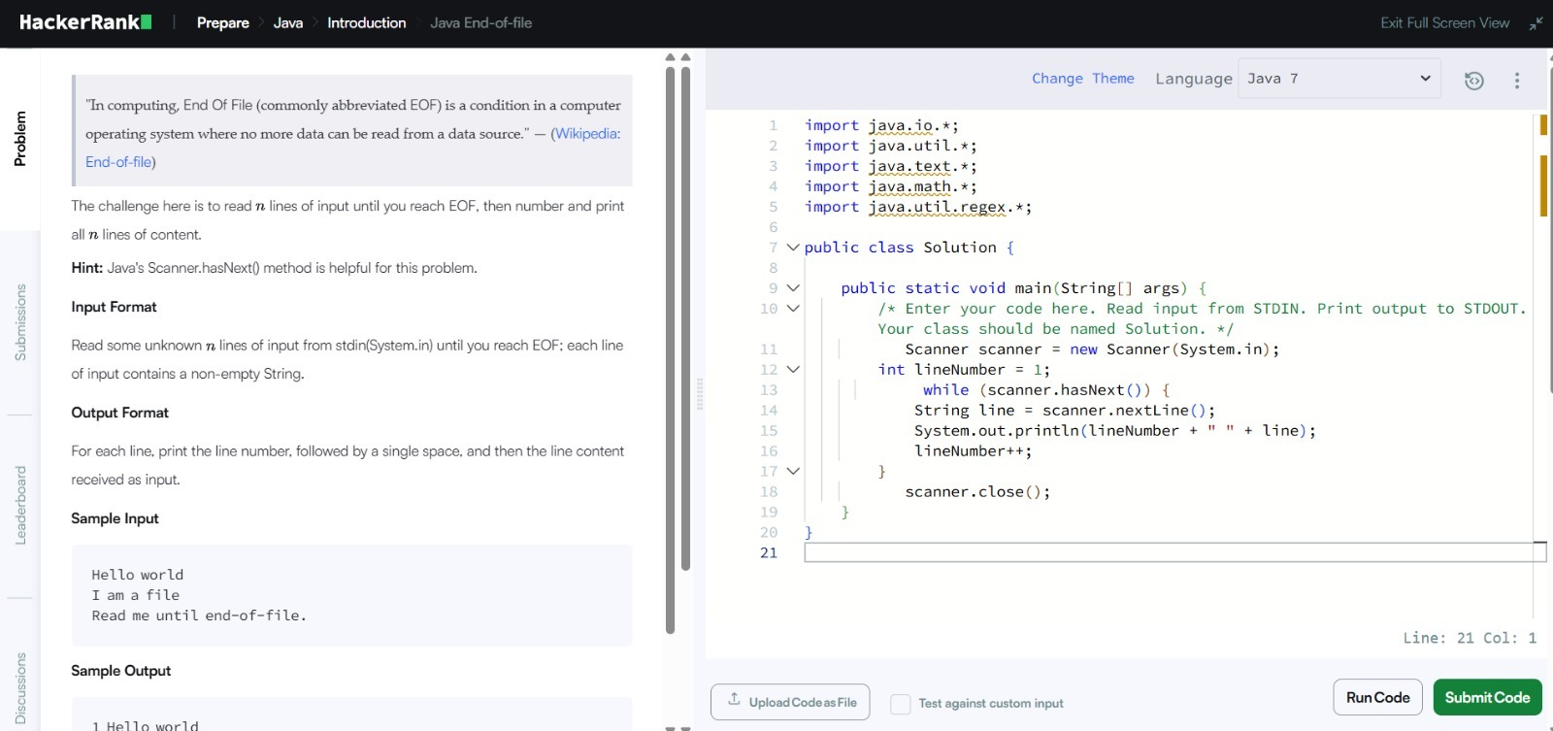
The code reads one lowercase string A from input using Scanner, reverses it using new StringBuilder(A).reverse().toString(), then checks if the original string equals the reversed string with A.equals(reversed).
If they are the same (palindrome, e.g. "madam"), it prints "Yes"; otherwise, it prints "No".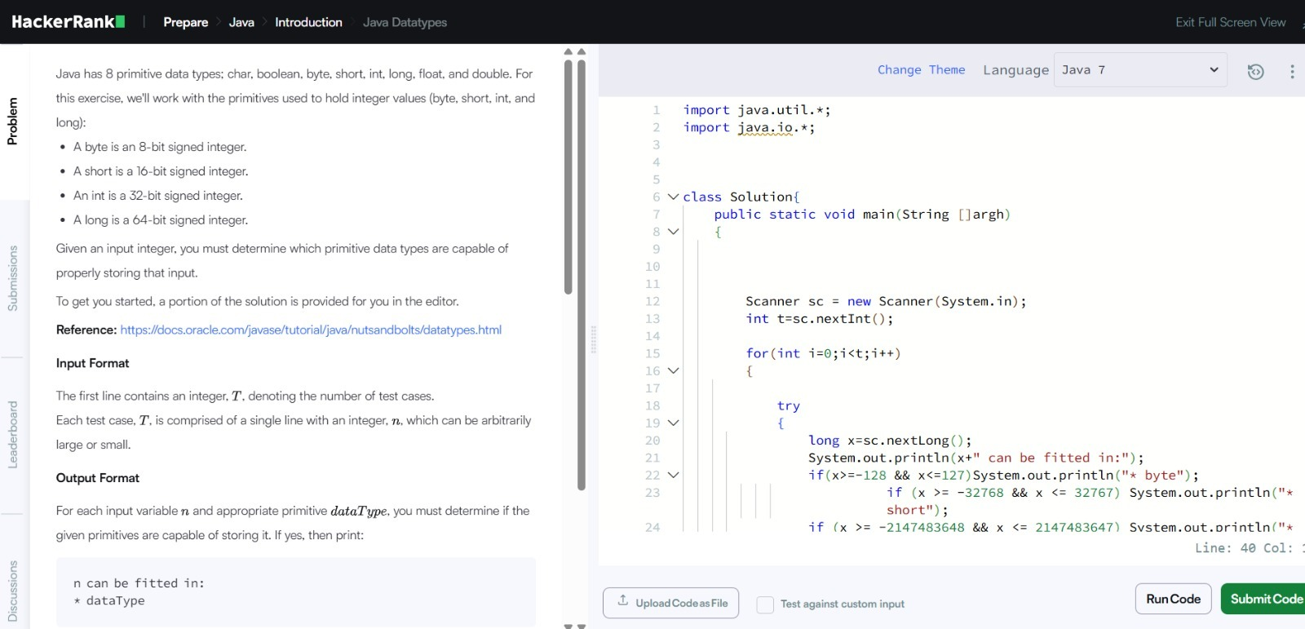
The code reads an integer T (number of test cases), then for each of T lines reads a long integer x (using nextLong() to handle large numbers safely), and checks which of Java's integer primitive types can store it without overflow:
* byte if -128 ≤ x ≤ 127
* short if -32,768 ≤ x ≤ 32,767
* int if -2,147,483,648 ≤ x ≤ 2,147,483,647
* Long always (since x is read as long)
It prints "x can be fitted in:" followed by the matching types (one per line with "* " prefix) for each test case. If none of the smaller types fit, only "* long" is printed.

Lab Task :06

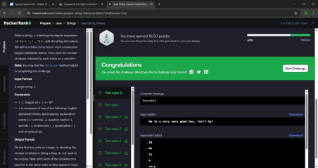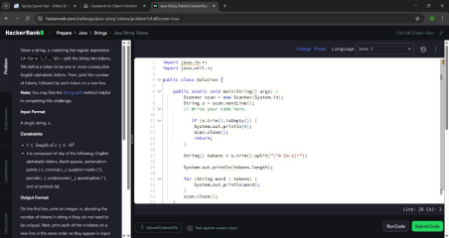
The program reads a string from the user and splits it into tokens (words) using any non-alphabetic characters as separators. It uses the regex [^A-Za-z]+ to identify and remove punctuation, spaces, and symbols. Then it prints the total number of tokens found, followed by each token on a new line. If the input is empty, it simply prints 0 and exits.
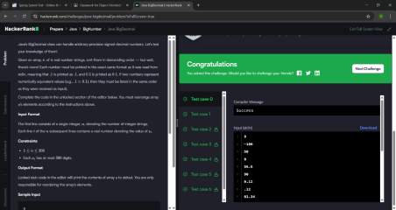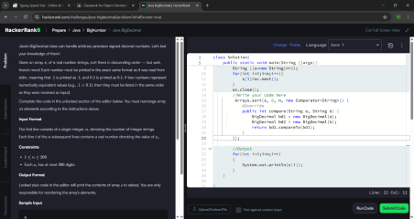
The program reads an array of number strings and sorts them in descending order using Java's BigDecimal class for accurate comparison. A custom Comparator is used where bd2.compareTo(bd1) ensures descending order (largest first). BigDecimal is used instead of regular numbers because it handles very large or precise decimals without losing accuracy. Finally, it loops through the sorted array and prints each number exactly as it was originally entered
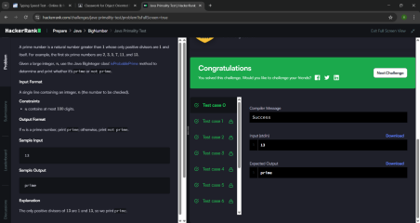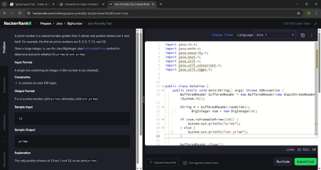
The program reads a large number (up to 100 digits) as a string and converts it into a BigInteger since normal int or long can't handle that size. It then uses Java's built-in isProbablePrime(100) method to check if the number is prime, where 100 is the certainty level (higher = more accurate). Based on the result, it simply prints either "prime" or "not prime".
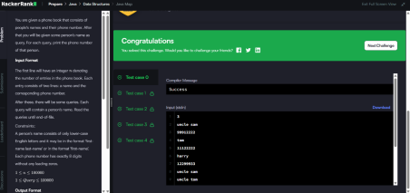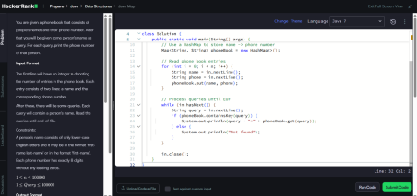
The program uses a HashMap to store a phone book where each person's name is the key and their phone number is the value. It first reads all the contacts and saves them into the map, then processes search queries one by one until the end of input. If the queried name exists in the map, it prints the name and number in name=number format, otherwise it prints "Not found".
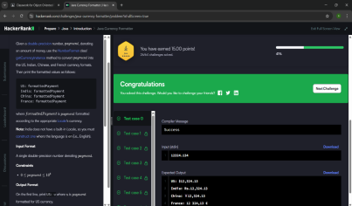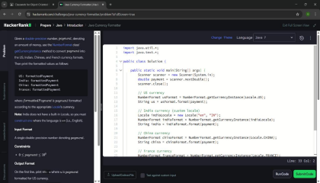
The program reads a decimal number and formats it as currency for four different countries using Java's NumberFormat.getCurrencyInstance() method. For US, China, and France it uses built in Locale settings, but for India it manually creates a custom Locale since Java doesn't have one built-in. It then prints each formatted currency value with the country label (US, India, China, France) in the required format.
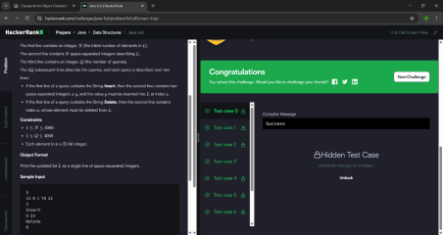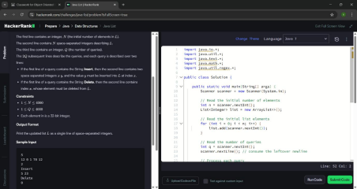
The program creates an ArrayList and fills it with an initial set of numbers read from input. It then processes Q queries where each query is either "Insert" (which adds a value at a specific index) or "Delete" (which removes an element at a specific index) using ArrayList's built-in add() and remove() methods. After all queries are done, it prints the final list as space-separated integers on one line.
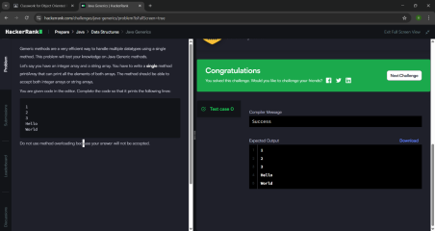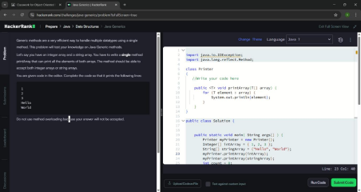
The code uses Java Generics to create a single printArray method that can work with any data type, whether integers or strings. The <T> before the method means it accepts any type of array, so one method handles both Integer[] and String[] without needing separate methods. It simply loops through whatever array is passed in and prints each element on a new line.
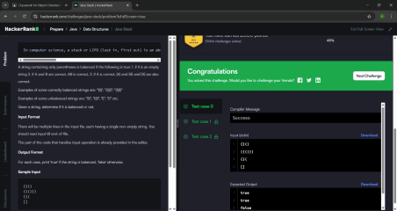
The program checks if a string of parentheses is balanced using a Stack data structure. It loops through each character — if it's an opening bracket (, {, [) it pushes it onto the stack, and if it's a closing bracket it checks whether the top of the stack has the matching opener. If all brackets match and the stack is empty at the end, it prints "true", otherwise "false".

